S4587681

Aadil

***Assignment***

***\*\*Additional Requirement is attached at the End***

***Requirements***

Small Industrial PC spare parts company Called ‘Aadil08’ wants to set up the computing environment for their Finance and Accounting Department with high available services. The design requested will consist of an Application server, Domain Controller and a Storage server.

The application server primarily focused on running the software and application required for the finance department will be used by Senior 2 accountants in their daily task. End of every week 1 more accountant will be joining them to support the final review done at the end of each week. The server will host two Virtual Machines (aadilVH-1, aadilVH-2) one as a running application server in use and the other as running backup for failover cluster. Both the VMs embedded in one cluster

The Domain controller server here is the main computer that controls our other servers with active directory services. (aadilADC)

The storage server (aadilStorage) is used mainly to store the application servers’ data. It is accessible by 50 Employees in the department for accounting references and repository. Server will consist of two storage disks (mStorage-1, mStorage-2). Both the Main application server and Fail over cluster are connect to the same storage server using it as a shared server.Consists of 3 iSCSI Disks which are shared

The Company’s environment will need the following implementation:

-Application Server

-Domain Controller

-Storage Server

-Failover cluster with Two Nodes

***Analysis and mapping to technical requirements***

‘Aadil Hardware’ Company is to setup the computing environment for their Finance Department. The department needs four servers, Failover Cluster server (aadilVH-1) for the accountants, Application Server (aadilVH-2), Storage server (aadilStorage) for shared storage access, Domain Controller (aadilADC). The department network segment is 172.20.10.0/24, gateway 172.20.10.1 (domain controller).

[technical requirement: Four VMs are required, with Four IPs in the range of 172.20.10.0/24.

***CLUSTER COMPACT STRUCTURE***

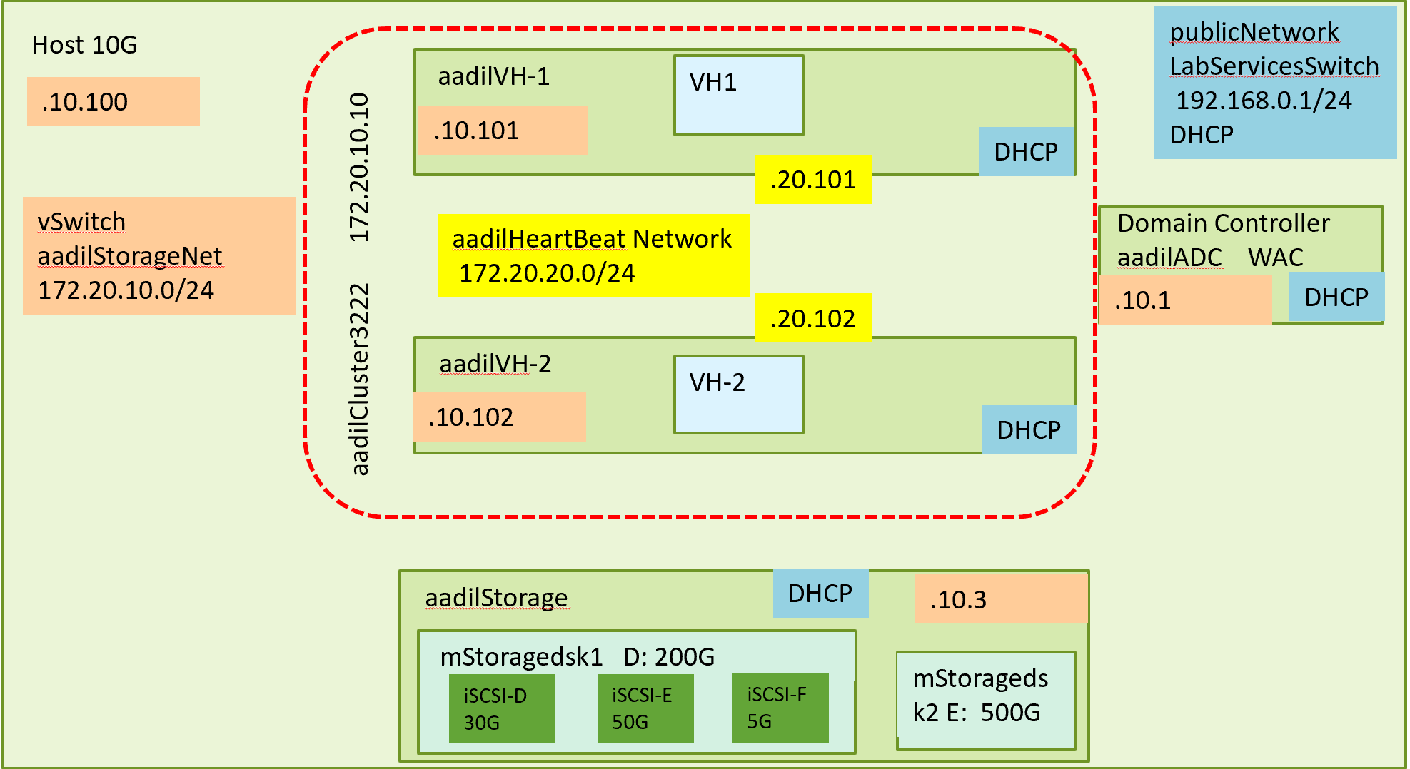

***Technical Requirement:***

aadilADC : Domain Controller

CPU: 3vCPUs + 1 for the system = 4 vCPUs

Memory: 3G, assigned 3G since it is set up to be our master controller

-Non-Dynamic memory allocation. Usage is stable with one control

Hard Disk: 10G OS 10G applications 10G for storage. Total 30G

-Non-Dynamic, the use is relatively stable, which makes it

predictable

Virtual Switches: aadilStorageNet, LabServicesSwitch

Networks and Macs

For aadilStorageNet: 172.20.10.1/24 00-00-03-90-01-01

For LabServiceSwitch: DHCP 00-00-03-90-01-02

Administrator Password: yuanStudy1

aadilVH-1: Failover Cluster Application Server

CPU: 4vCPUs (3 editors constantly running the

Application plus 1 vCPU for the system)

Memory: 3x2G per staff + 2G system = 8G

-Accounting application/software requires heavy usage of memory

Hence assigned 2G per accountant

-Non-Dynamic because the requirement is relatively stable

-When the system memory is limited, dynamic memory is also

Possible with minimum start-up 2G

Hard Disk: -10G for OS + 20G for application + 20G working disk for each staff

90G Total

-non dynamic expansion disk. The workload is relatively stable and

Can be predicted easily

Virtual Switches: aadilStorageNet, aadilHeartBeatNet, LabServicesSwitch

Networks and Macs

For aadilStorageNet: 172.20.10.101/24 00-00-03-90-02-01

For aadilHeartBeatNet: 172.20.20.101/24 00-00-03-90-02-02

For LabServicesSwitch: DHCP 00-00-03-90-02-03

Administrator Password: yuanStudy1

aadilVH-2: Application Server

CPU: 4vCPUs (3 editors constantly running the

Application plus 1 vCPU for the system)

Memory: 3x2G per staff + 2G system = 8G

-Accounting application/software requires heavy usage of memory

Hence assigned 2G per accountant

-Non-Dynamic because the requirement is relatively stable

-When the system memory is limited, dynamic memory is also

Possible with minimum start-up 2G

Hard Disk: -10G for OS + 20G for application + 20G working disk for each staff

90G Total

-non dynamic expansion disk. The workload is relatively stable and

Can be predicted easily

Virtual Switches: aadilStorageNet, aadilHeartBeatNet, LabServicesSwitch

Networks and Macs

For aadilStorageNet: 172.20.10.102/24 00-00-03-90-03-01

For aadilHeartBeatNet: 172.20.20.102/24 00-00-03-90-03-02

For LabServicesSwitch: DHCP 00-00-03-90-03-03

Administrator Password: yuanStudy1

aadilStorage: Shared Storage access

CPU: 3vCPUs

Memory: 2G x 3vCPUs + 2G for system = 8G

-6G is assigned since this is a shared storage point it enables for

Fast temporary read and write speeds when accessing data

-Dynamic because the requirement for accessing the data is burst

Mode. Minimum 2G and maximum 8G

Hard Disk: -10G for OS + 5G for application + 500G working Hard disk space.

515G Total

-non dynamic expansion disk. The workload is relatively stable and

Can be predicted easily

Virtual Switches: aadilStorageNet, LabServicesSwitch

Networks and Macs

For aadilStorageNet: 172.20.10.3/24 00-00-03-90-04-01

For LabServicesSwitch: DHCP 00-00-03-90-04-02

Administrator Password: yuanStudy1

**Design**

aadilADC: Domain Controller

CPU: 4 vCPUs

Memory: 3G

Hard Disk: 30G Non-Dynamic

Virtual Switches: aadilStorageNet, LabServicesSwitch

Networks and Macs

For aadilStorageNet: 172.20.10.1/24 00-00-03-90-01-01

For LabServiceSwitch: DHCP 00-00-03-90-01-02

Administrator Password: yuanStudy1

aadilVH-1: Application Server

CPU: 4vCPUs

Memory: 3G Non-Dynamic

Hard Disk: 90G Total Non-dynamic

Virtual Switches: aadilStorageNet, aadilHeartBeatNet, LabServicesSwitch

Networks and Macs

For aadilStorageNet: 172.20.10.101/24 00-00-03-90-02-01

For aadilHeartBeatNet: 172.20.20.101/24 00-00-03-90-02-02

For LabServicesSwitch: DHCP 00-00-03-90-02-03

Administrator Password: yuanStudy1

aadilVH-2: Failover Cluster Application Server

CPU: 4vCPUs

Memory: 3G Non-Dynamic

Hard Disk: 90G Total

Virtual Switches: aadilStorageNet, aadilHeartBeatNet, LabServicesSwitch

Networks and Macs

For aadilStorageNet: 172.20.10.102/24 00-00-03-90-03-01

For aadilHeartBeatNet: 172.20.20.102/24 00-00-03-90-03-02

For LabServicesSwitch: DHCP 00-00-03-90-03-03

Administrator Password: yuanStudy1

aadilStorage: Shared Storage access

CPU: 3vCPUs

Memory: 3G Dynamic

Hard Disk: 515G Total

Virtual Switches: aadilStorageNet, LabServicesSwitch

Networks and Macs

For aadilStorageNet: 172.20.10.3/24 00-00-03-90-04-01

For LabServicesSwitch: DHCP 00-00-03-90-04-02

Administrator Password: yuanStudy1

***Program and Steps***

1. Creating Switches In Host

#aadilStorageNet, aadilHeartbeatNet

$names = @("aadilStorageNet","aadilHeartbeatNet")

For ($i=0; $i -lt $names.Length; $i++) {

$temname=$names[$i]

New-VMSwitch -name $temname -SwitchType Internal

}

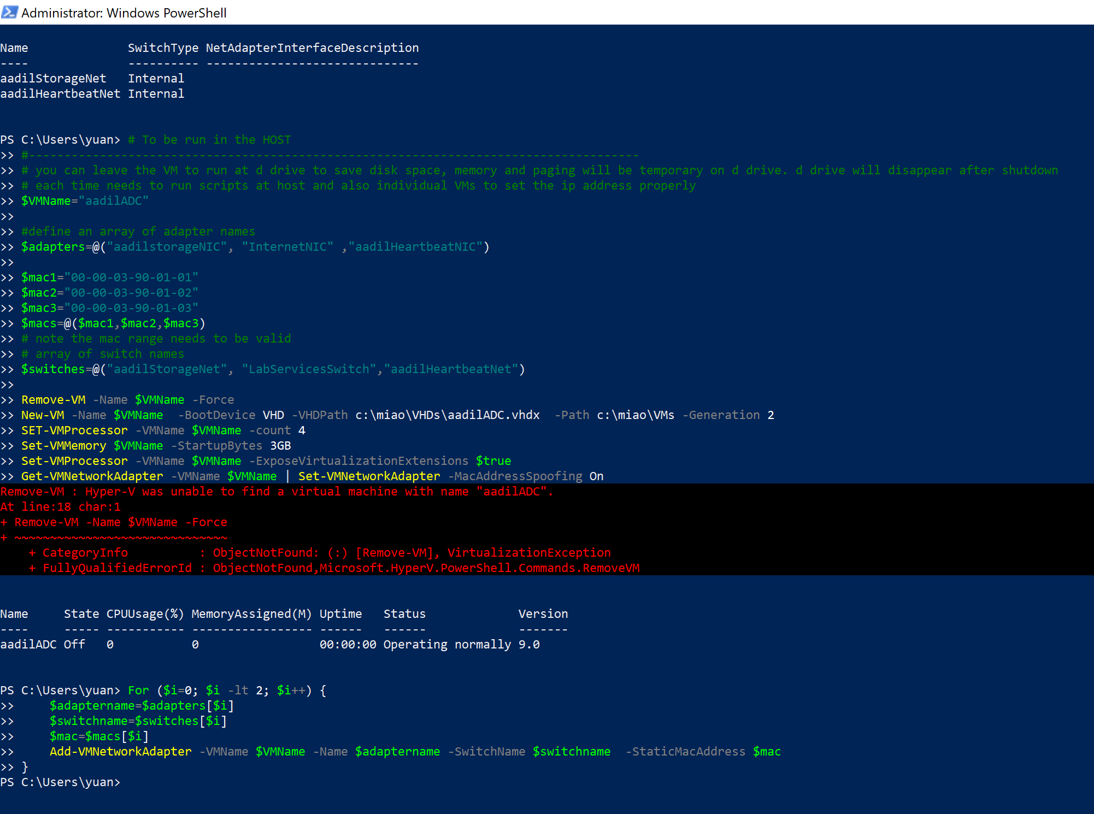

*Fig1.1 (Creating Switches aadilStorageNet and aadilHeartbeatNet)*

1. aadilADC Domain Controller Server

$VMName="aadilADC"

#define an array of adapter names

$adapters=@("aadilstorageNIC", "InternetNIC" ,"aadilHeartbeatNIC")

$mac1="00-00-03-90-01-01"

$mac2="00-00-03-90-01-02"

$mac3="00-00-03-90-01-03"

$macs=@($mac1,$mac2,$mac3)

# note the mac range needs to be valid

# array of switch names

$switches=@("aadilStorageNet", "LabServicesSwitch","aadilHeartbeatNet")

Remove-VM -Name $VMName -Force

New-VM -Name $VMName -BootDevice VHD -VHDPath c:\miao\VHDs\aadilADC.vhdx -Path c:\miao\VMs -Generation 2

SET-VMProcessor –VMName $VMName –count 4

Set-VMMemory $VMName -StartupBytes 3

Set-VMProcessor -VMName $VMName -ExposeVirtualizationExtensions $true

Get-VMNetworkAdapter -VMName $VMName | Set-VMNetworkAdapter -MacAddressSpoofing On

#add adapters to the VM, with proper switch and mac address

#---------------------------------------------------

#remove unnecessary adapters

remove-VMNetworkAdapter -VMName $VMName -Name "Network Adapter"

#only cluster node needs hearbeat network

For ($i=0; $i -lt 2; $i++) {

$adaptername=$adapters[$i]

$switchname=$switches[$i]

$mac=$macs[$i]

Add-VMNetworkAdapter -VMName $VMName -Name $adaptername -SwitchName $switchname -StaticMacAddress $mac

}



*Fig 2.1 (Creating VM aadilADC and seeding Adaptors)*

$VMName="aadilADC"

# add hyperv and admin functions

rename-computer $VMName

#Install-WindowsFeature -Name Hyper-V -IncludeManagementTools -Restart

# relogin again after hyper-v is installed

$adapters=@("aadilstorageNIC", "InternetNIC" ,"aadilHeartbeatNIC")

$mac1="00-00-03-90-01-01"

$mac2="00-00-03-90-01-02"

$mac3="00-00-03-90-01-03"

$macs=@($mac1,$mac2,$mac3)

#allow ping through firewall

netsh advfirewall firewall add rule name="ICMP Allow incoming V4 echo request" protocol=icmpv4:8,any dir=in action=allow

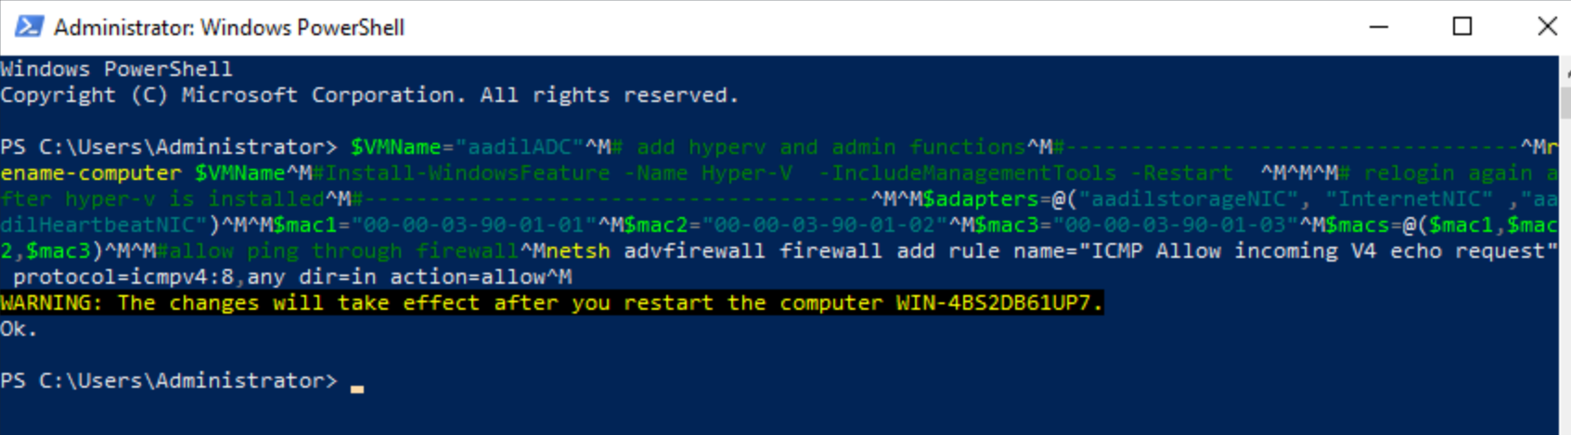

*Fig 2.2 (Firewall restrictions updated for aadilADC)*

#config storage network

$mac1="00-00-03-90-01-01"

$adaptername=$adapters[0]

$ipadd='172.20.10.1'

$gateway='172.20.10.1’

#based on the mac address to find the adapter’s interface netif

$netif=(Get-NetAdapter | where {$_.MacAddress -eq $mac1}).InterfaceIndex

$netname=(Get-NetAdapter | where {$_.MacAddress -eq $mac1}).name

#remove the existing IP to add new address

Remove-NetIpAddress -InterfaceIndex $netif -AddressFamily IPv4 -Confirm:$false

Remove-NetRoute -InterfaceIndex $netif -AddressFamily IPv4 -Confirm:$false

New-NetIPAddress -IPAddress $ipadd -prefixlength 24 -DefaultGateway $gateway -InterfaceIndex $netif

rename-netadapter -name $netname -newName $adaptername

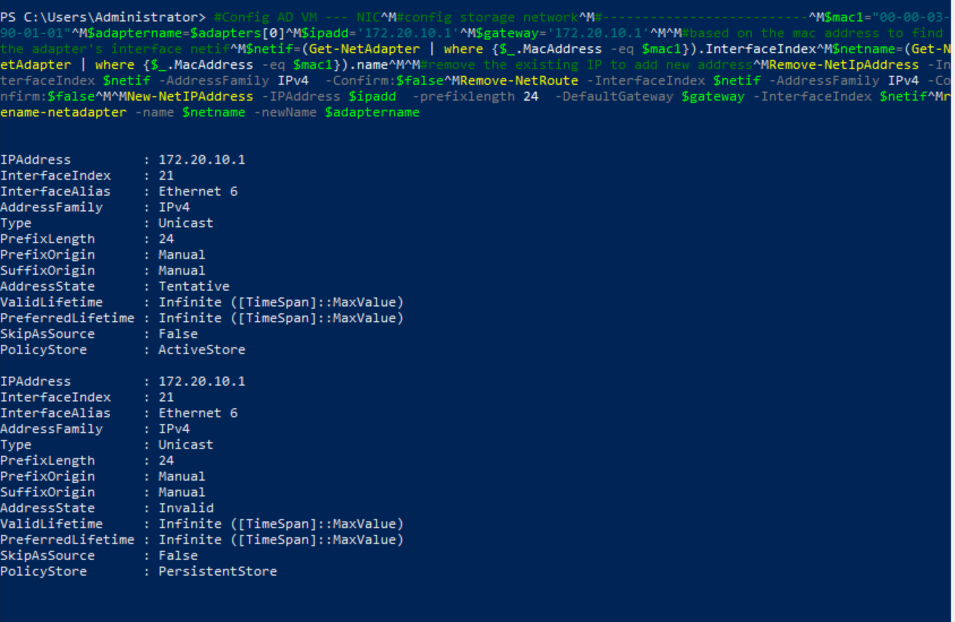

*Fig 2.3 (Config aadilStorageNet for aadilADC)*

#config Internet

#--------------------------

$mac1="00-00-03-90-01-02"

$adaptername=$adapters[1]

#based on the mac address to find the adapter’s interface netif

$netif=(Get-NetAdapter | where {$_.MacAddress -eq $mac1}).InterfaceIndex

$netname=(Get-NetAdapter | where {$_.MacAddress -eq $mac1}).name

rename-netadapter -name $netname -newName $adaptername

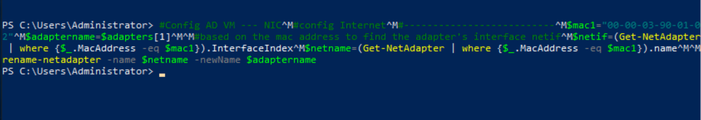

*Fig 2.4 (Config internetNIC for aadilADC)*

#enable domain and dns

#-------------------------------------

#show current computer name

$ENV:computername

Install-windowsfeature -name AD-Domain-Services -IncludeManagementTools

Get-Command -Module ADDSDeployment

#Get-Help <cmdlet name>

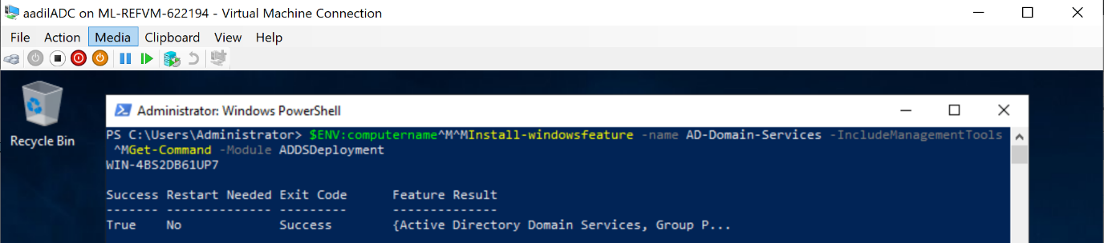

*Fig 2.5 (Installing Active Directory for aadilADC server)*

# domain controller normally is also a dns server

# this is the storageNet adapter mac address, find the interface netif

$mac1="00-00-03-90-01-01“

$ipadd='172.20.10.1'

$netif=(Get-NetAdapter | where {$_.MacAddress -eq $mac1}).InterfaceIndex

set-DnsClientServerAddress -InterfaceIndex $netif -ServerAddresses ($ipadd)

#save the following scripts into a script file e.g. adc.ps1 and run the script (too many lines)

Install-ADDSForest `

-DomainName "Aadil.NIT3222" `

-CreateDnsDelegation:$false `

-DatabasePath "C:\Windows\NTDS" `

-DomainMode "7" `

-DomainNetbiosName "AadilNIT3222" `

-ForestMode "7" `

-InstallDns:$true `

-LogPath "C:\Windows\NTDS" `

-NoRebootOnCompletion:$True `

-SysvolPath "C:\Windows\SYSVOL" `

-Force:$true

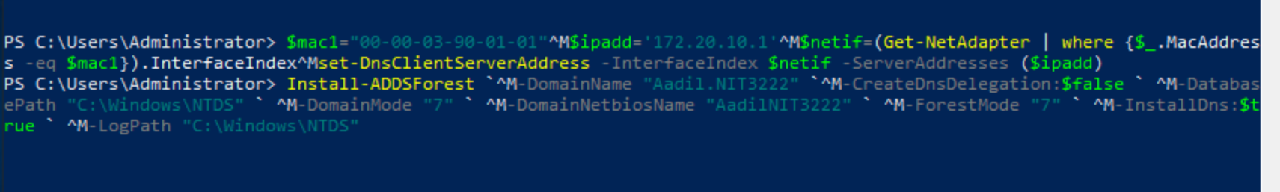

*Fig 2.6 (Creating a new Domain name Aadil.NIT3222)*

Get-Service adws,kdc,netlogon,dns

Get-ADDomainController

Get-ADDomain aadil.NIT3222

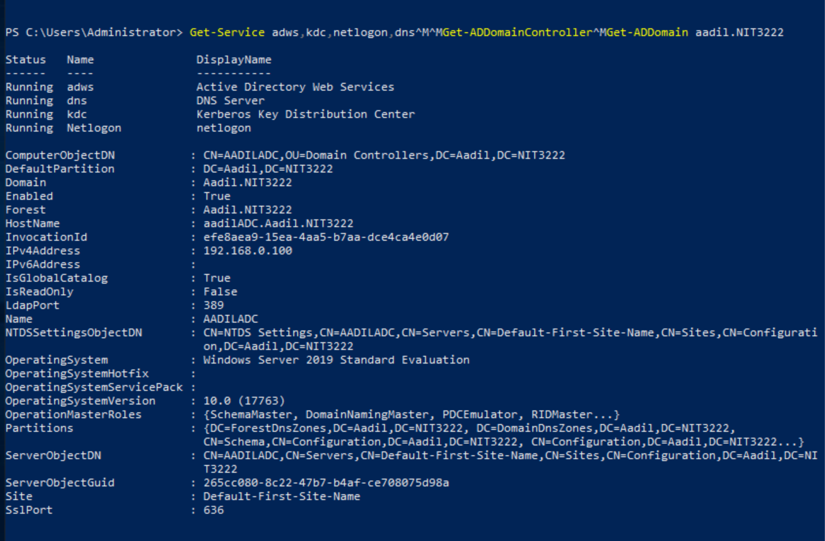

*Fig 2.7 (Active Directory status)*

1. aadilVH-1 Failover Cluster Application Server

#create miaoVH-1 VM

#-------------------------------

# leave the VM to run at d drive to save disk space, memory and paging will be temporary on d drive. d drive will disappear after shutdown

# each time needs to run scripts at host and also individual VMs to set the ip address properly ;

$VMName="aadilVH-1"

$adapters=@("aadilstorageNIC", "InternetNIC" ,"aadilHeartbeatNIC")

$mac1="00-00-03-90-02-01"

$mac2="00-00-03-90-02-02"

$mac3="00-00-03-90-02-03"

$macs=@($mac1,$mac2,$mac3)

$switches=@("aadilStorageNet", "LabServicesSwitch","aadilHeartbeatNet")

# note the mac range needs to be valid

Remove-VM -Name $VMName -Force

New-VM -Name $VMName -BootDevice VHD -VHDPath c:\miao\VHDs\aadilVH-1.vhdx -Path c:\miao\VMs -Generation 2

SET-VMProcessor –VMName $VMName –count 4

Set-VMMemory $VMName -StartupBytes 3GB

Set-VMProcessor -VMName $VMName -ExposeVirtualizationExtensions $true

Get-VMNetworkAdapter -VMName $VMName | Set-VMNetworkAdapter -MacAddressSpoofing On

remove-VMNetworkAdapter -VMName $VMName -Name "Network Adapter"

#only cluster node needs heartbeat network

For ($i=0; $i -lt 3; $i++) {

$adaptername=$adapters[$i]

$switchname=$switches[$i]

$mac=$macs[$i]

Add-VMNetworkAdapter -VMName $VMName -Name $adaptername -SwitchName $switchname -StaticMacAddress $mac

}

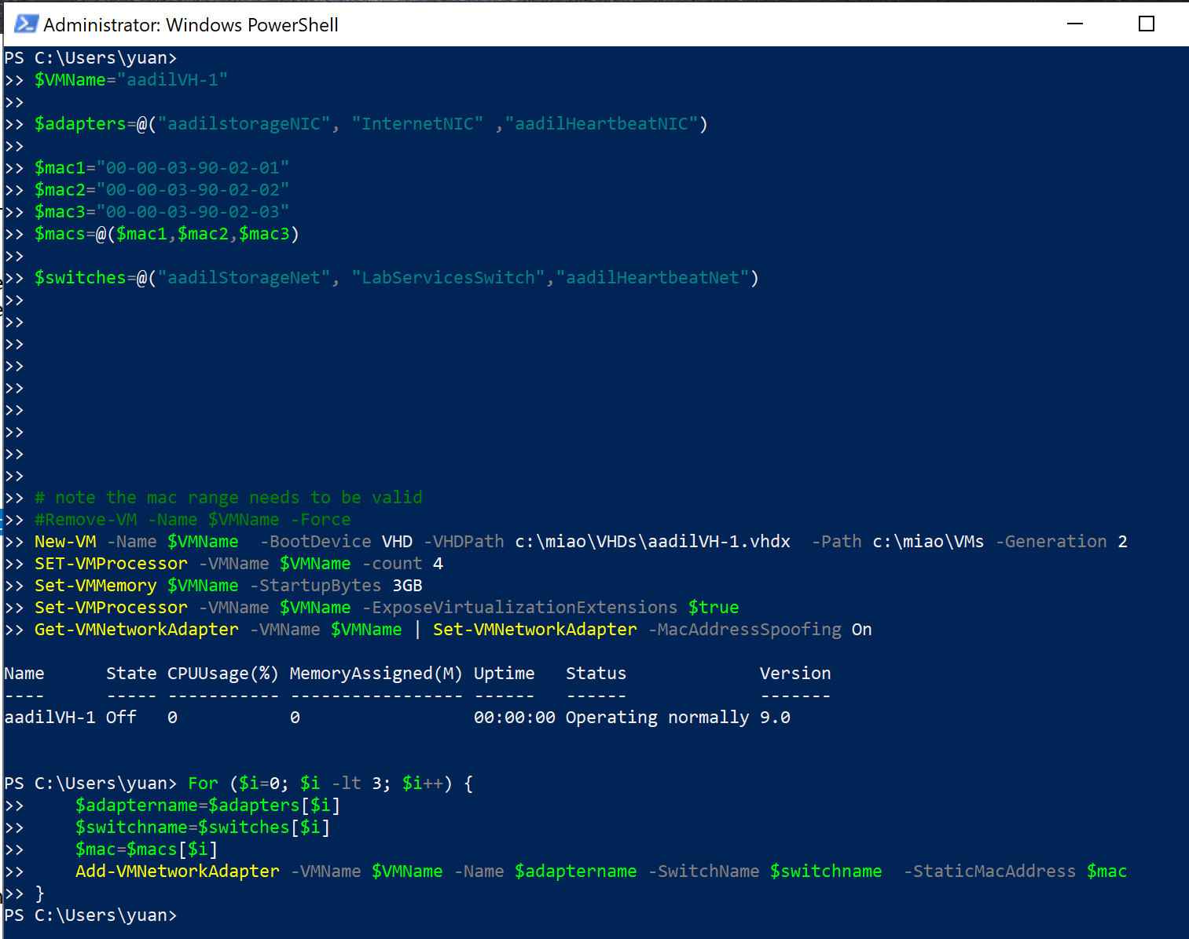

*Fig 3.1 (Creating VM aadilVH-1 with adaptors seeded)*

# login to the domain controller to setup, once have vhdx, later do not need to repeat

#-----------------------------------------------

$VMName="aadilVH-1"

# add hyperv and admin functions

#-----------------------------------

rename-computer $VMName

#Install-WindowsFeature -Name Hyper-V -IncludeManagementTools -Restart

#reboot and login again

#allow ping through firewall

netsh advfirewall firewall add rule name="ICMP Allow incoming V4 echo request" protocol=icmpv4:8,any dir=in action=allow

$adapters=@("aadilstorageNIC", "InternetNIC" ,"aadilHeartbeatNIC")

$mac1="00-00-03-90-02-01"

$mac2="00-00-03-90-02-02"

$mac3="00-00-03-90-02-03"

$macs=@($mac1,$mac2,$mac3)

#config storage network

#--------------------------

$i=0

$mac1=$macs[$i]

$adaptername=$adapters[$i]

$ipadd='172.20.10.101'

$gateway='172.20.10.1'

$netif=(Get-NetAdapter | where {$_.MacAddress -eq $mac1}).InterfaceIndex

$netname=(Get-NetAdapter | where {$_.MacAddress -eq $mac1}).name

Remove-NetIpAddress -InterfaceIndex $netif -AddressFamily IPv4 -Confirm:$false

Remove-NetRoute -InterfaceIndex $netif -AddressFamily IPv4 -Confirm:$false

New-NetIPAddress -IPAddress $ipadd -prefixlength 24 -DefaultGateway $gateway -InterfaceIndex $netif

rename-netadapter -name $netname -newName $adaptername

#add dns

#set the dns server

set-DnsClientServerAddress -InterfaceIndex $netif -ServerAddresses ($gateway)

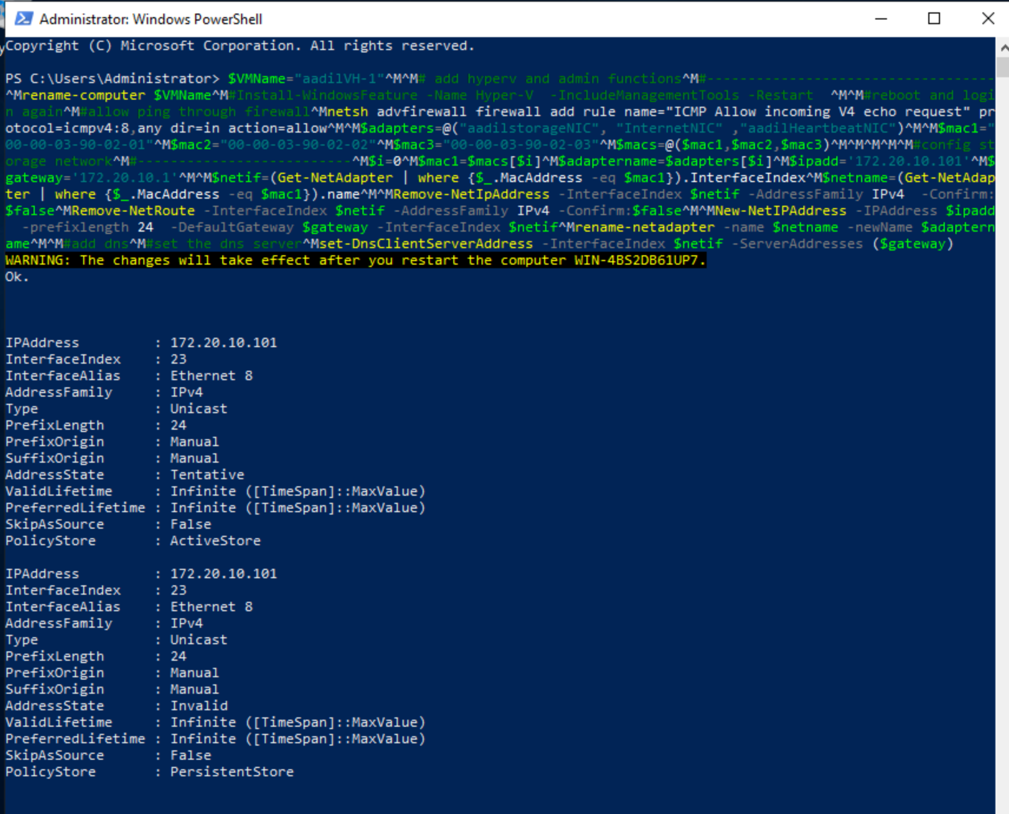

*Fig 3.2 (Config aadilStorage Network adaptor for aadilVH-1)*

#aadilheartbeat network

#--------------------------

$i=2

$mac1=$macs[$i]

$adaptername=$adapters[$i]

$ipadd='172.20.20.101'

$gateway='172.20.20.102'

$netif=(Get-NetAdapter | where {$_.MacAddress -eq $mac1}).InterfaceIndex

$netname=(Get-NetAdapter | where {$_.MacAddress -eq $mac1}).name

Remove-NetIpAddress -InterfaceIndex $netif -AddressFamily IPv4 -Confirm:$false

Remove-NetRoute -InterfaceIndex $netif -AddressFamily IPv4 -Confirm:$false

New-NetIPAddress -IPAddress $ipadd -prefixlength 24 -DefaultGateway $gateway -InterfaceIndex $netif

rename-netadapter -name $netname -newName $adaptername

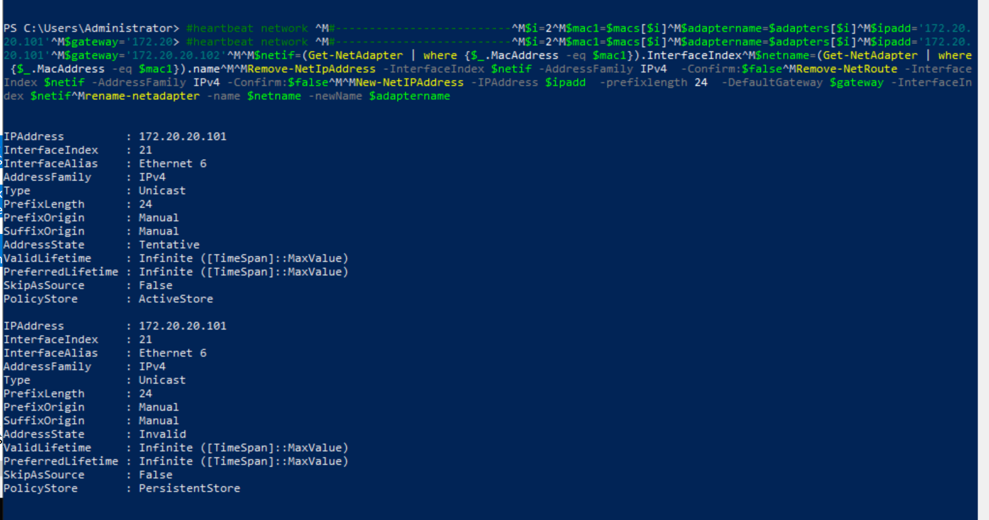

*Fig 3.3* *(Config aadilHeartbeat Network adaptor for aadilVH-1)*

#config internet network

#--------------------------

$i=1

$mac1=$macs[$i]

$adaptername=$adapters[$i]

$netif=(Get-NetAdapter | where {$_.MacAddress -eq $mac1}).InterfaceIndex

$netname=(Get-NetAdapter | where {$_.MacAddress -eq $mac1}).name

rename-netadapter -name $netname -newName $adaptername

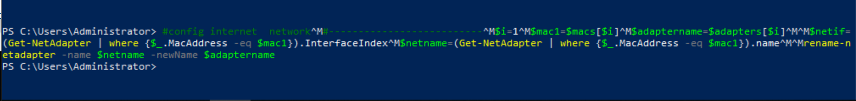

*Fig 3.4 (Config Internet Network adaptor for aadilVH-1)*

#join domain domain and dns

#-------------------------------------

#add mStorage1 to the domain, if the image is with domain, then this step can be skipped

# use administrator password: yuanStudy1

add-computer –domainname aadil.NIT3222 -Credential aadil\administrator -restart –force

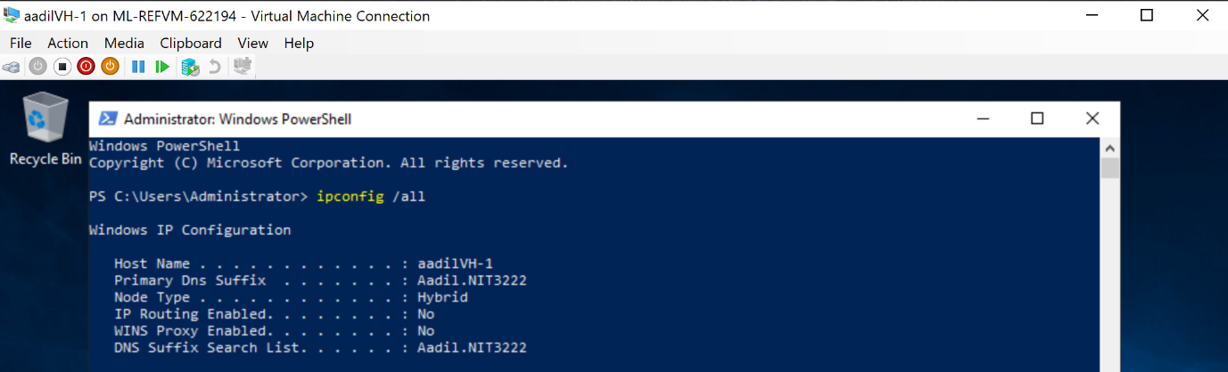

*Fig 3.4 (aadilVH-1 is added under the Domain Controller)*

#install file server role and iscsi target server

Install-WindowsFeature -Name FS-iSCSITarget-Server -IncludeAllSubFeature -IncludeManagementTools

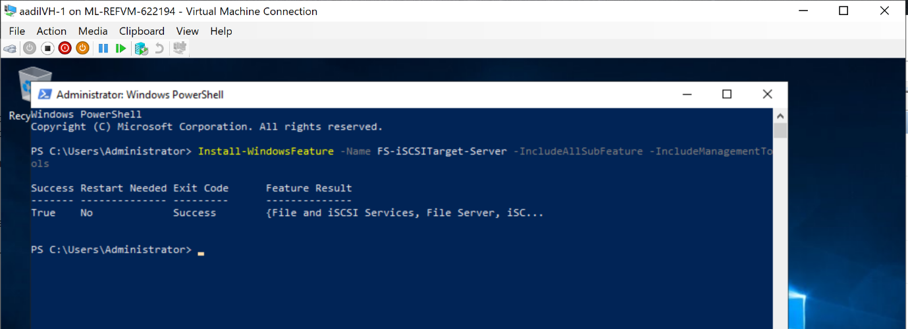

*Fig 3.5 (iSCSI manager feature installed for aadilVH-1)*

# install fallover cluster role with miaoVH-1, miaoVH-2

Install-WindowsFeature -Name Failover-Clustering ÐIncludeManagementTools

Install-WindowsFeature -name Multipath-IO

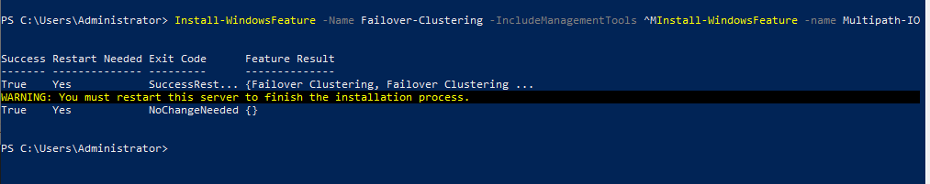

*Fig 3.5 (Failover cluster feature is installed for aadilVH-1)*

1. aadilVH-2 Application Server

$VMName="aadilVH-2"

$adapters=@("aadilstorageNIC", "InternetNIC" ,"aadilHeartbeatNIC")

$mac1="00-00-03-90-03-01"

$mac2="00-00-03-90-03-02"

$mac3="00-00-03-90-03-03"

$macs=@($mac1,$mac2,$mac3)

$switches=@("aadilStorageNet", "LabServicesSwitch","aadilHeartbeatNet")

# note the mac range needs to be valid

Remove-VM -Name $VMName -Force

New-VM -Name $VMName -BootDevice VHD -VHDPath c:\miao\VHDs\aadilVH-1.vhdx -Path c:\miao\VMs -Generation 2

SET-VMProcessor –VMName $VMName –count 4

Set-VMMemory $VMName -StartupBytes 3GB

Set-VMProcessor -VMName $VMName -ExposeVirtualizationExtensions $true

Get-VMNetworkAdapter -VMName $VMName | Set-VMNetworkAdapter -MacAddressSpoofing On

remove-VMNetworkAdapter -VMName $VMName -Name "Network Adapter"

#only cluster node needs heartbeat network

For ($i=0; $i -lt 3; $i++) {

$adaptername=$adapters[$i]

$switchname=$switches[$i]

$mac=$macs[$i]

Add-VMNetworkAdapter -VMName $VMName -Name $adaptername -SwitchName $switchname -StaticMacAddress $mac

}

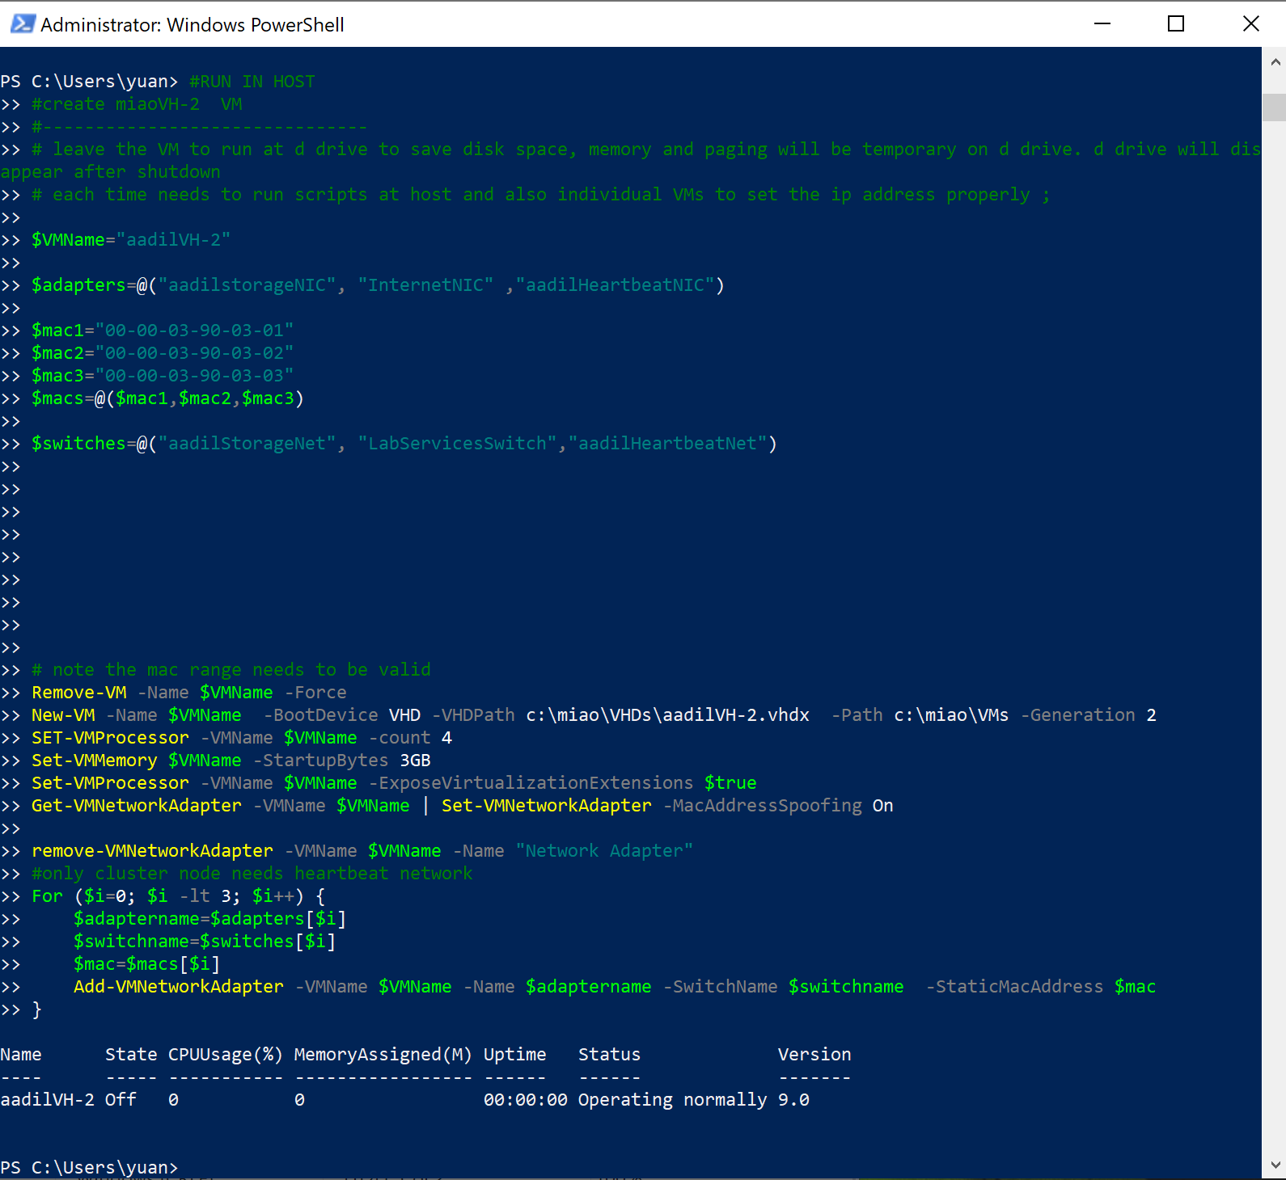

*Fig 4.1 (Creating VM aadilVH-2 with adaptors seeded)*

# login to the domain controller to setup, once have vhdx, later do not need to repeat

#-----------------------------------------------

$VMName="aadilVH-2"

# add hyperv and admin functions

#-----------------------------------

rename-computer $VMName

#Install-WindowsFeature -Name Hyper-V -IncludeManagementTools -Restart

#reboot and login again

#allow ping through firewall

netsh advfirewall firewall add rule name="ICMP Allow incoming V4 echo request" protocol=icmpv4:8,any dir=in action=allow

$adapters=@("aadilstorageNIC", "InternetNIC" ,"aadilHeartbeatNIC")

$mac1="00-00-03-90-03-01"

$mac2="00-00-03-90-03-02"

$mac3="00-00-03-90-03-03"

$macs=@($mac1,$mac2,$mac3)

#config storage network

#--------------------------

$i=0

$mac1=$macs[$i]

$adaptername=$adapters[$i]

$ipadd='172.20.10.102'

$gateway='172.20.10.1'

$netif=(Get-NetAdapter | where {$_.MacAddress -eq $mac1}).InterfaceIndex

$netname=(Get-NetAdapter | where {$_.MacAddress -eq $mac1}).name

Remove-NetIpAddress -InterfaceIndex $netif -AddressFamily IPv4 -Confirm:$false

Remove-NetRoute -InterfaceIndex $netif -AddressFamily IPv4 -Confirm:$false

New-NetIPAddress -IPAddress $ipadd -prefixlength 24 -DefaultGateway $gateway -InterfaceIndex $netif

rename-netadapter -name $netname -newName $adaptername

#add dns

#set the dns server

set-DnsClientServerAddress -InterfaceIndex $netif -ServerAddresses ($gateway)

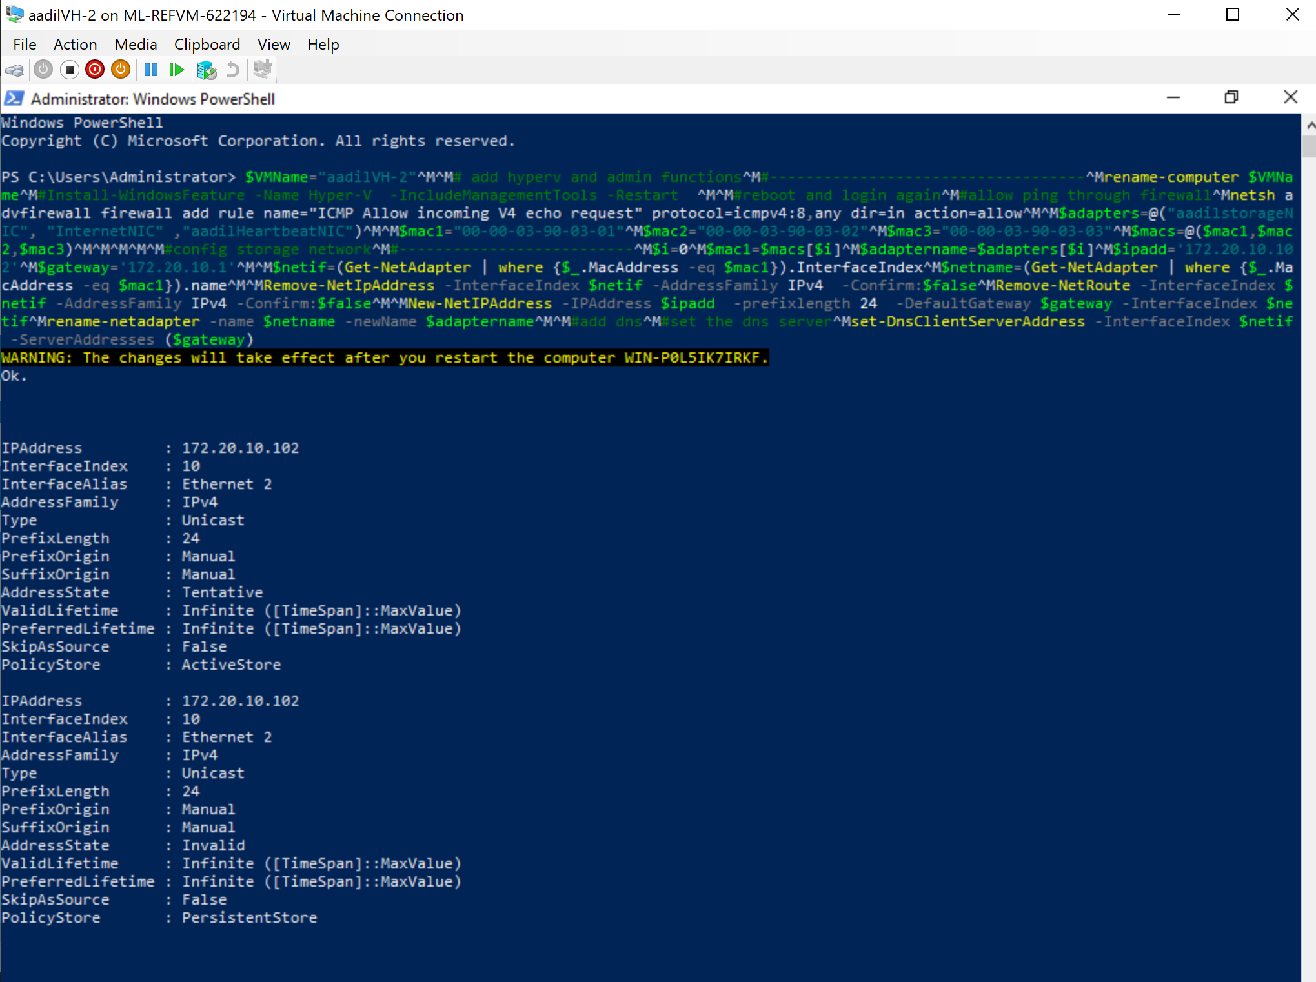

*Fig 4.2 (Config aadilStorage Network adaptor for aadilVH-2)*

#aadilheartbeat network

#--------------------------

$i=2

$mac1=$macs[$i]

$adaptername=$adapters[$i]

$ipadd='172.20.20.102'

$gateway='172.20.20.102'

$netif=(Get-NetAdapter | where {$_.MacAddress -eq $mac1}).InterfaceIndex

$netname=(Get-NetAdapter | where {$_.MacAddress -eq $mac1}).name

Remove-NetIpAddress -InterfaceIndex $netif -AddressFamily IPv4 -Confirm:$false

Remove-NetRoute -InterfaceIndex $netif -AddressFamily IPv4 -Confirm:$false

New-NetIPAddress -IPAddress $ipadd -prefixlength 24 -DefaultGateway $gateway -InterfaceIndex $netif

rename-netadapter -name $netname -newName $adaptername

#config internet network

#--------------------------

$i=1

$mac1=$macs[$i]

$adaptername=$adapters[$i]

$netif=(Get-NetAdapter | where {$_.MacAddress -eq $mac1}).InterfaceIndex

$netname=(Get-NetAdapter | where {$_.MacAddress -eq $mac1}).name

rename-netadapter -name $netname -newName $adaptername

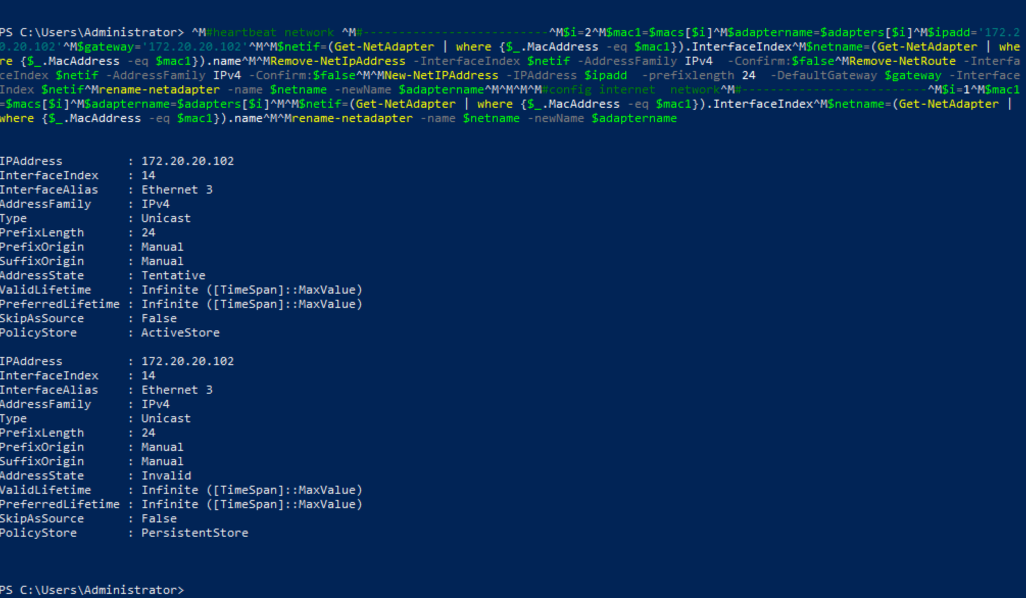

*Fig 4.3 (Config aadilHeartbeat Network adaptor and Internet adaptor for aadilVH-2)*

#join domain domain and dns

#-------------------------------------

#add mStorage1 to the domain, if the image is with domain, then this step can be skipped

# use administrator password: yuanStudy1

add-computer –domainname aadil.NIT3222 -Credential aadil\administrator -restart –force

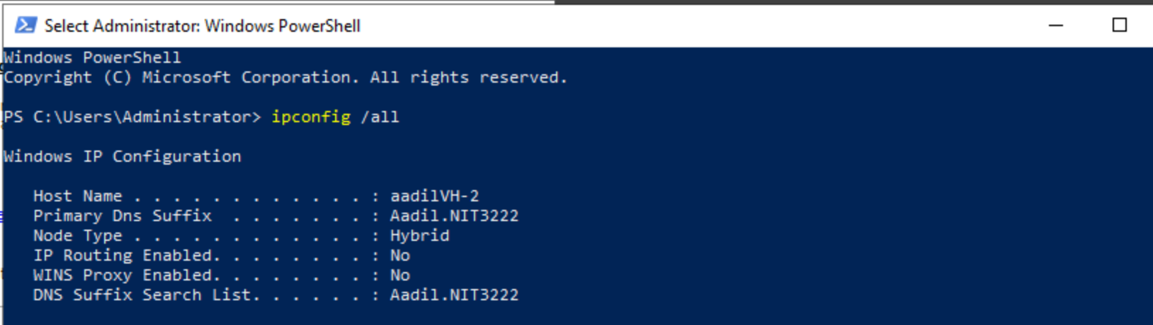

*Fig 4.4 (aadilVH-2 is added under the Domain Controller)*

#install file server role and iscsi target server

Install-WindowsFeature -Name FS-iSCSITarget-Server -IncludeAllSubFeature -IncludeManagementTools

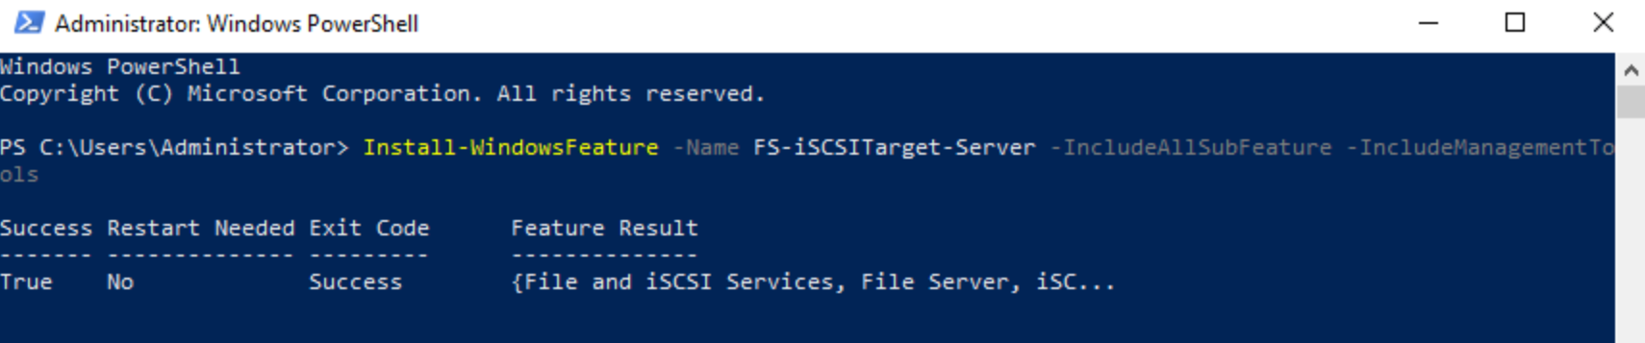

*Fig 4.5 (iSCSI manager feature installed for aadilVH-2)*

# install fallover cluster role with aadilVH-1, aadilVH-2

Install-WindowsFeature -Name Failover-Clustering ÐIncludeManagementTools

Install-WindowsFeature -name Multipath-IO



*Fig 4.6 (Failover cluster feature is installed for aadilVH-2)*

1. aadilStorage Shared Storage Server

$VMName="aadilStorage"

$adapters=@("aadilstorageNIC", "InternetNIC" ,"aadilHeartbeatNIC")

$mac1="00-00-03-90-04-01"

$mac2="00-00-03-90-04-02"

$mac3="00-00-03-90-04-03"

$macs=@($mac1,$mac2,$mac3)

$switches=@("aadilStorageNet", "LabServicesSwitch","aadilHeartbeatNet")

# note the mac range needs to be valid

Remove-VM -Name $VMName -Force

New-VM -Name $VMName -BootDevice VHD -VHDPath c:\miao\VHDs\aadilStorage.vhdx -Path c:\miao\VMs -Generation 2

SET-VMProcessor –VMName $VMName –count 3

Set-VMMemory $VMName -DynamicMemoryEnabled $true -MinimumBytes 2GB -StartupBytes 2GB -MaximumBytes 3GB -Priority 80 -Buffer 25

Set-VMProcessor -VMName $VMName -ExposeVirtualizationExtensions $true

Get-VMNetworkAdapter -VMName $VMName | Set-VMNetworkAdapter -MacAddressSpoofing On

remove-VMNetworkAdapter -VMName $VMName -Name "Network Adapter"

#only cluster node needs hearbeat network

For ($i=0; $i -lt 2; $i++) {

$adaptername=$adapters[$i]

$switchname=$switches[$i]

$mac=$macs[$i]

Add-VMNetworkAdapter -VMName $VMName -Name $adaptername -SwitchName $switchname -StaticMacAddress $mac

}

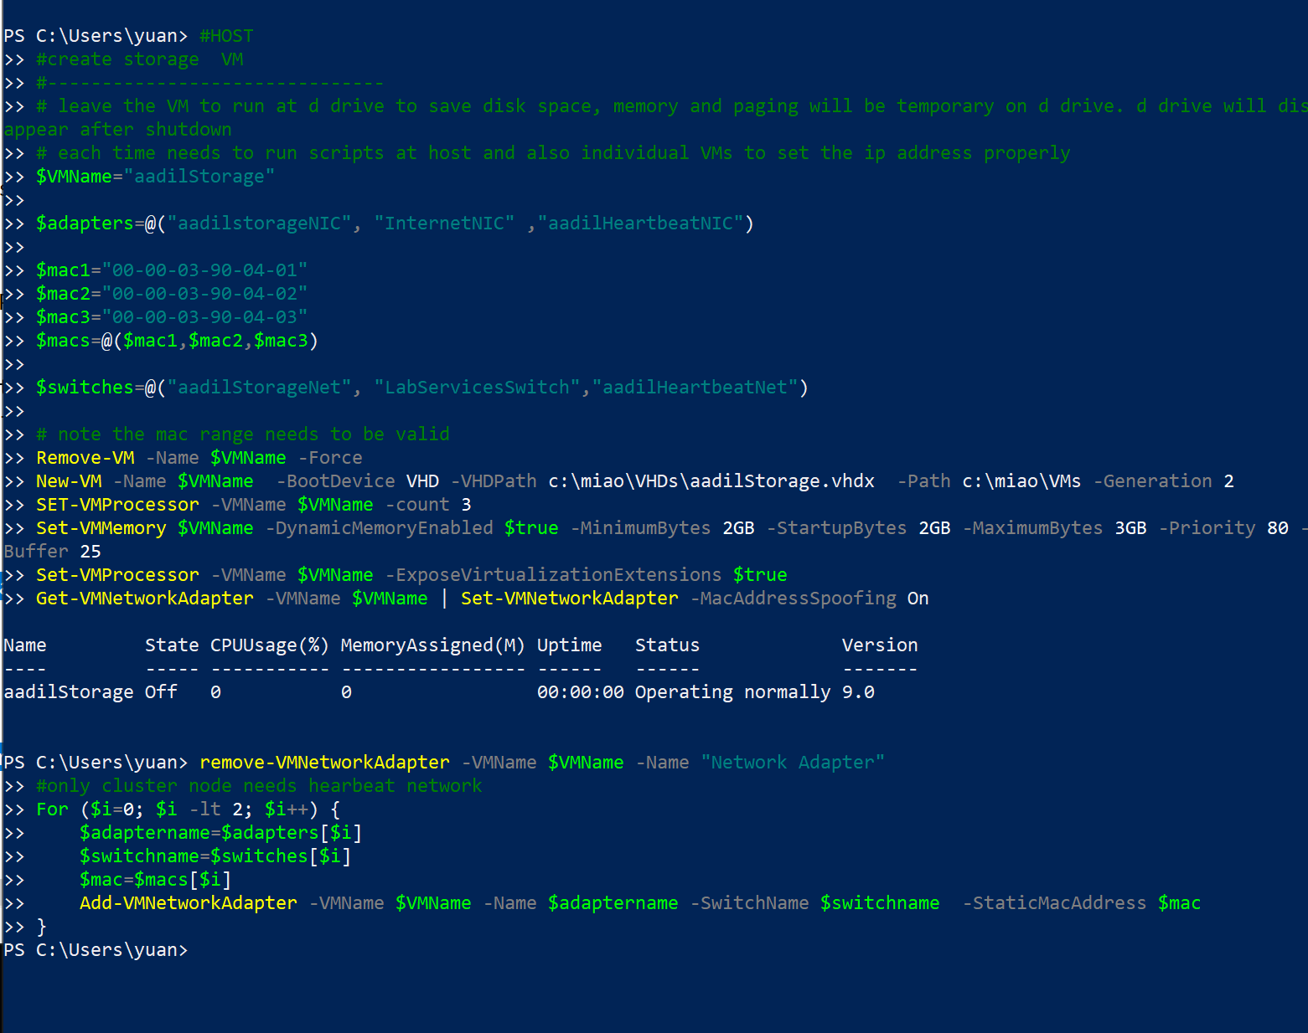

*Fig 5.1 (Creating VM aadilStorage with adaptors seeded)*

# create two virtual disk to be used as the iscsi disks

New-VHD -Path c:\miao\VHDs\mStorageDsk1.vhdx -SizeBytes 200GB

New-VHD -Path c:\miao\VHDs\mStorageDsk2.vhdx -SizeBytes 500GB

#attach the disks to the vm mStorage_1

Add-VMHardDiskDrive -VMName $VMName -Path c:\miao\VHDs\mStorageDsk1.vhdx -ControllerType SCSI -ControllerNumber 0

Add-VMHardDiskDrive -VMName $VMName -Path c:\miao\VHDs\mStorageDsk2.vhdx -ControllerType SCSI -ControllerNumber 0

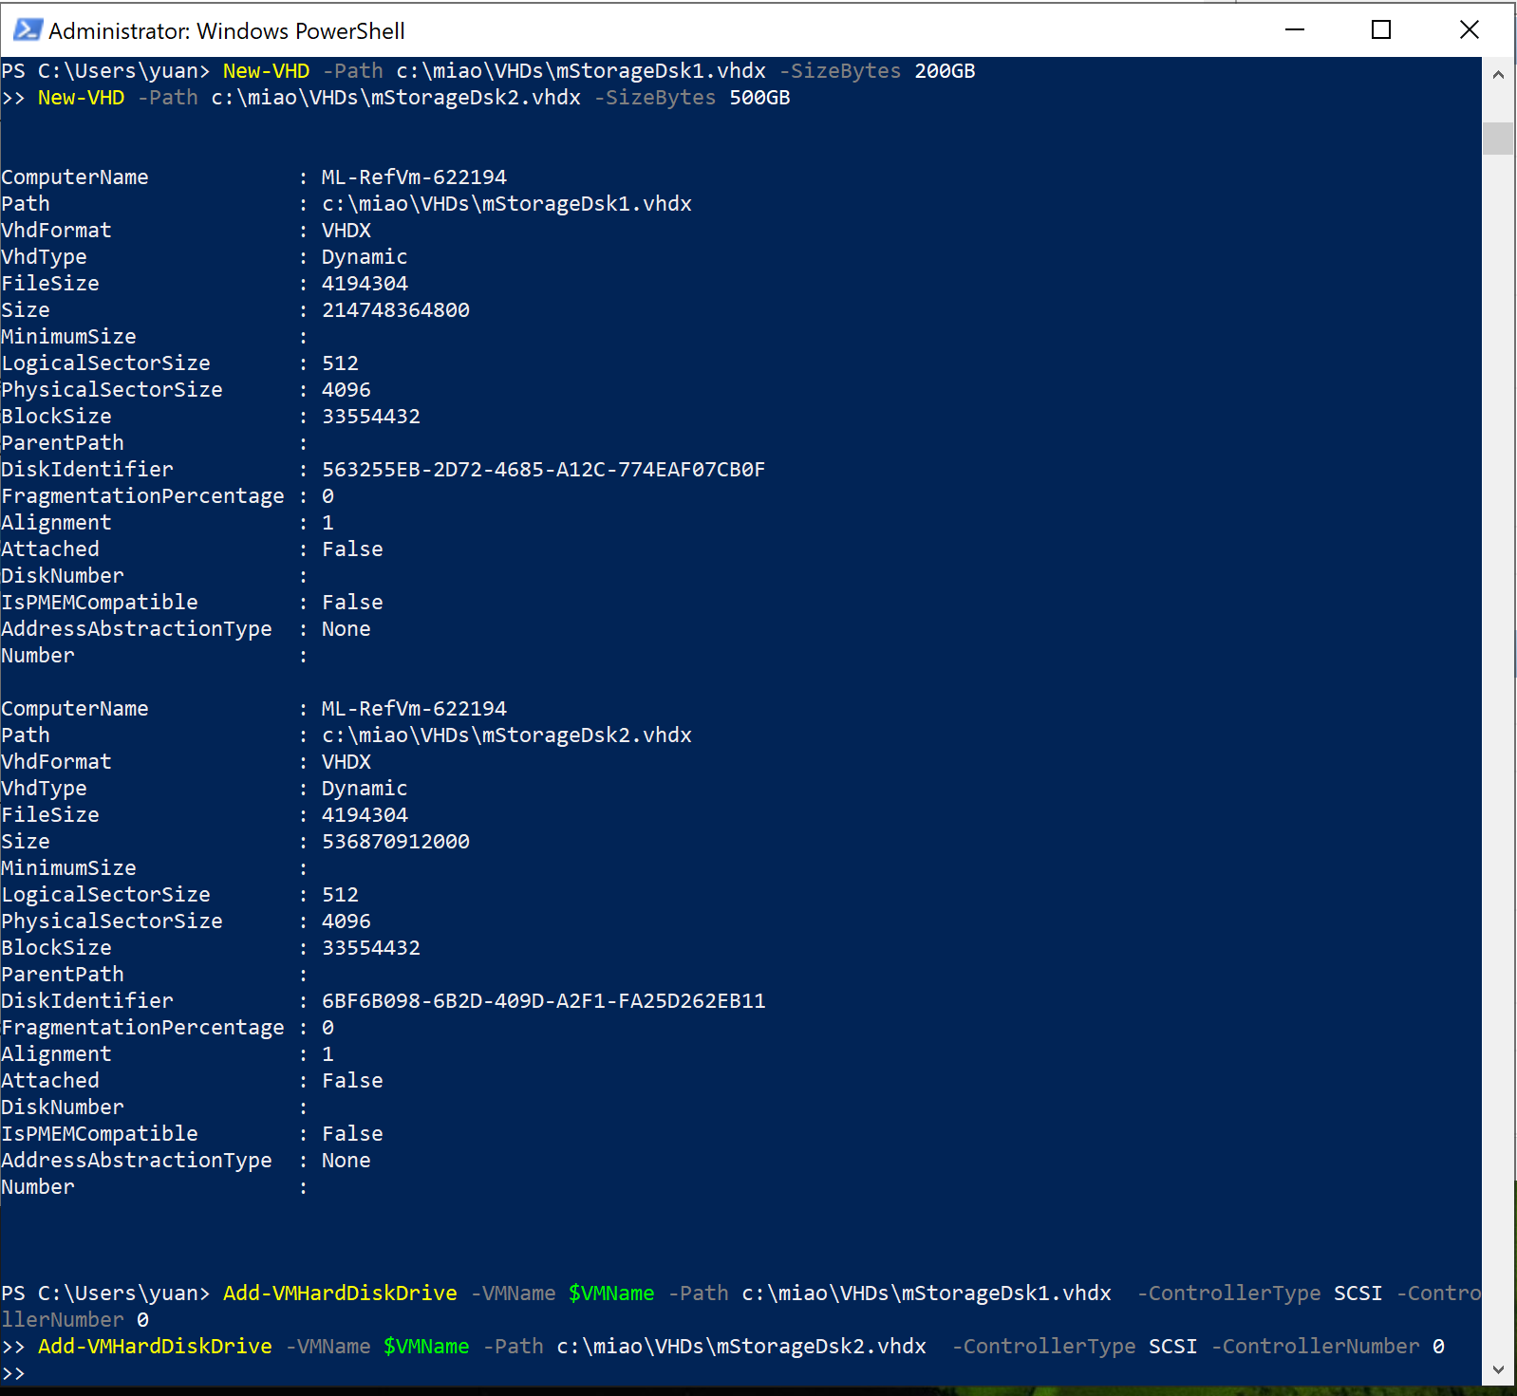

*Fig 5.2 (Creating 2 mStorage disks and assigning it to aadilStorage server)*

$VMName="aadilStorage"

# add hyperv and admin functions

#-----------------------------------

rename-computer $VMName

#Install-WindowsFeature -Name Hyper-V -IncludeManagementTools -Restart

#login again to run the next part

#-------------------------------------------

#allow ping through firewall

netsh advfirewall firewall add rule name="ICMP Allow incoming V4 echo request" protocol=icmpv4:8,any dir=in action=allow

$adapters=@("aadilStorageNIC", "InternetNIC" ,"aadilHeartbeatNIC")

$mac1="00-00-03-90-04-01"

$mac2="00-00-03-90-04-02"

$mac3="00-00-03-90-04-03"

$macs=@($mac1,$mac2,$mac3)

#config storage network

#--------------------------

$i=0

$mac1=$macs[$i]

$adaptername=$adapters[$i]

$ipadd='172.20.10.3'

$gateway='172.20.10.1'

$netif=(Get-NetAdapter | where {$_.MacAddress -eq $mac1}).InterfaceIndex

$netname=(Get-NetAdapter | where {$_.MacAddress -eq $mac1}).name

Remove-NetIpAddress -InterfaceIndex $netif -AddressFamily IPv4 -Confirm:$false

Remove-NetRoute -InterfaceIndex $netif -AddressFamily IPv4 -Confirm:$false

New-NetIPAddress -IPAddress $ipadd -prefixlength 24 -DefaultGateway $gateway -InterfaceIndex $netif

rename-netadapter -name $netname -newName $adaptername

#add dns

#set the dns server

set-DnsClientServerAddress -InterfaceIndex $netif -ServerAddresses ($gateway)

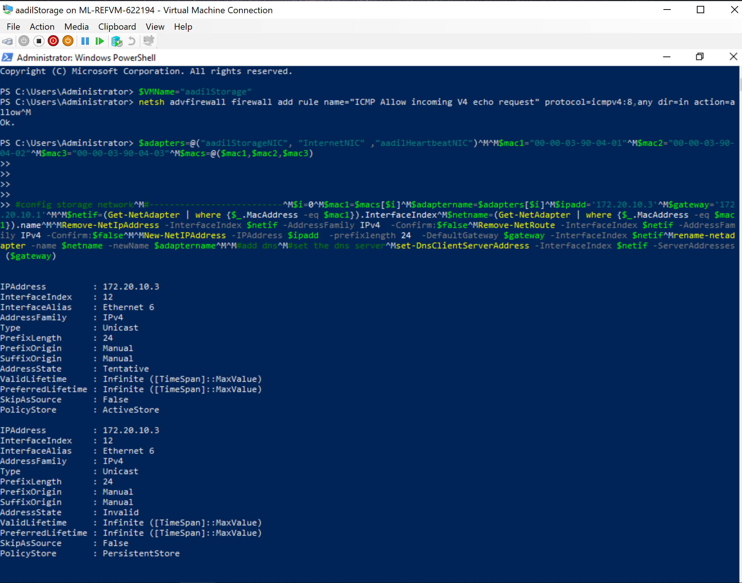

*Fig 5.3 (Config aadilStorage Network adaptor for aadilStorage)*

#config internet network

#--------------------------

$i=1

$mac1=$macs[$i]

$adaptername=$adapters[$i]

$netif=(Get-NetAdapter | where {$_.MacAddress -eq $mac1}).InterfaceIndex

$netname=(Get-NetAdapter | where {$_.MacAddress -eq $mac1}).name

rename-netadapter -name $netname -newName $adaptername

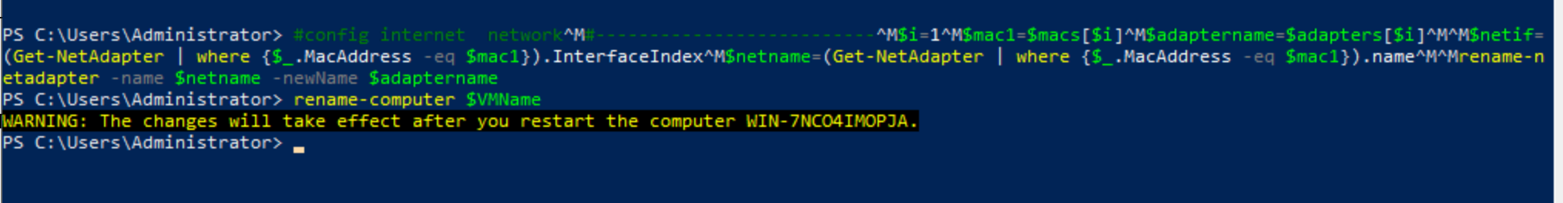

*Fig 5.4 (Config Internet Network adaptor for aadilStorage)*

1. iSCSI Disk Creation and Assigning to aadilVH-1, Aadil VH-2

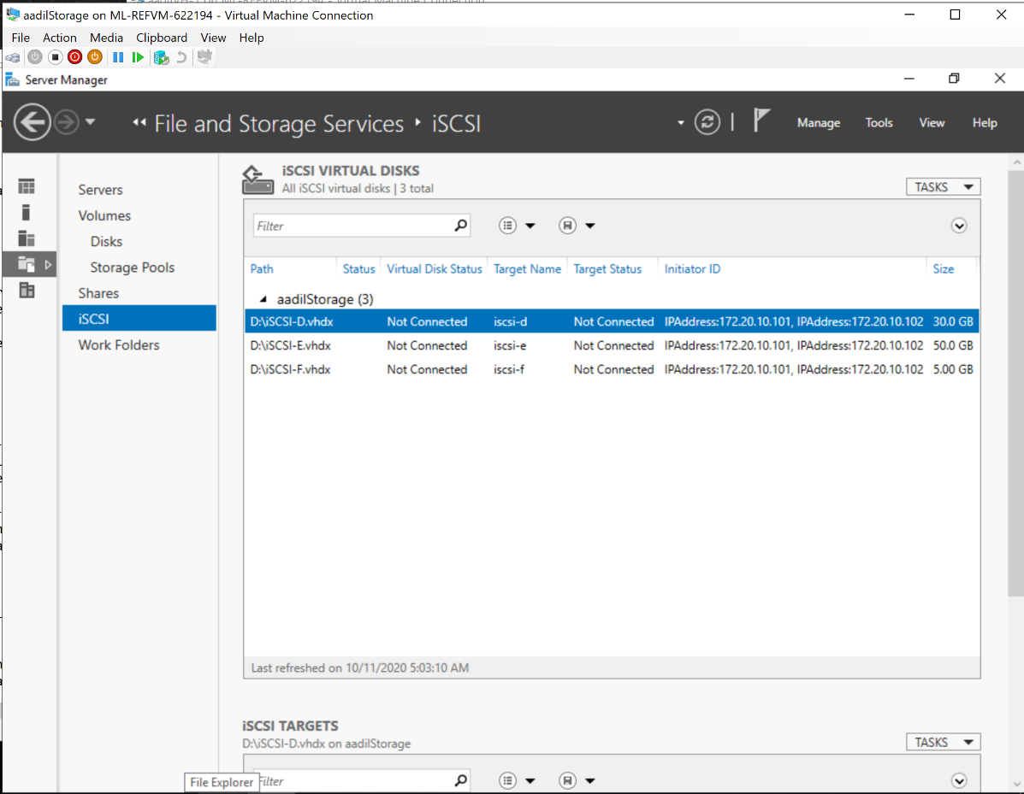

*Fig 6.1 (iSCSI Disks created)*

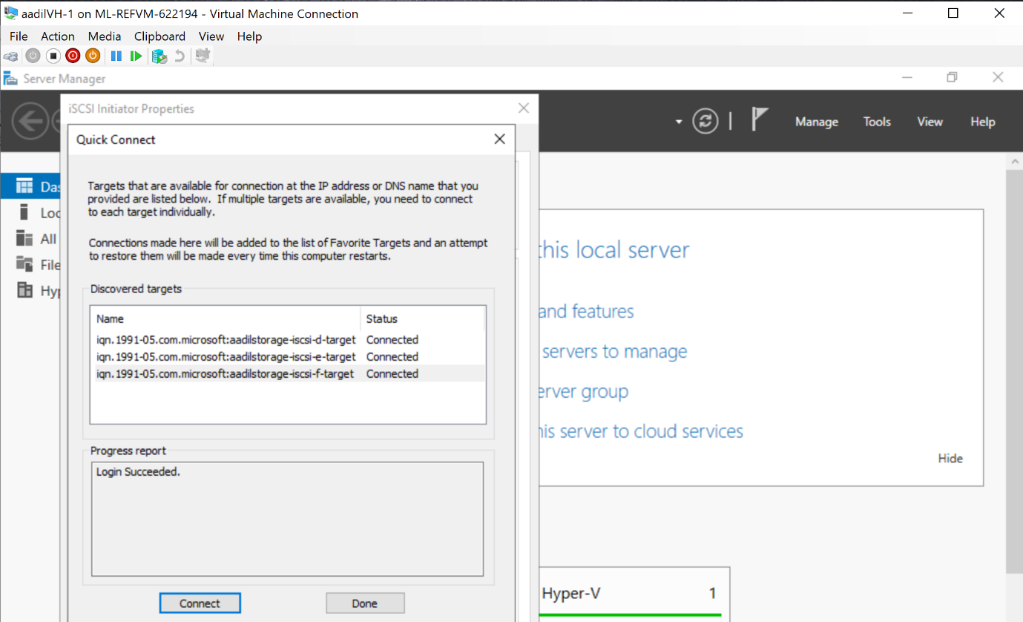

*Fig 6.2 (iSCSI disk Connected to aadilVH-1)*

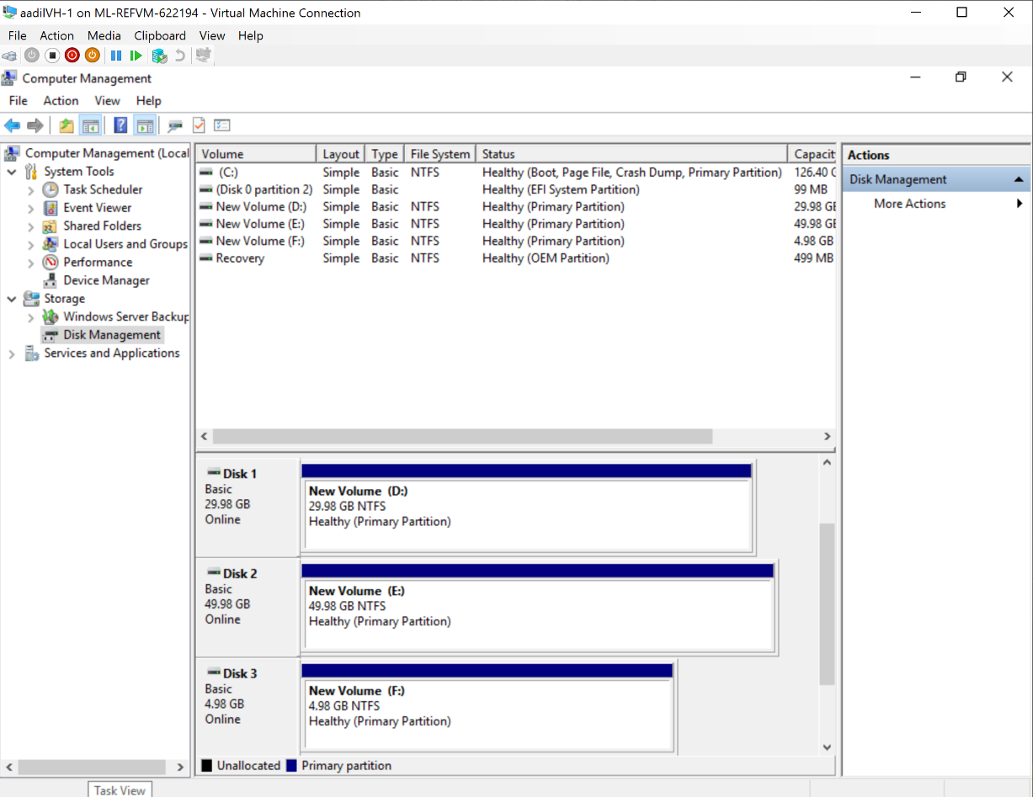

*Fig 6.3 (iSCSI disks Initialized to aadilVH-1)*

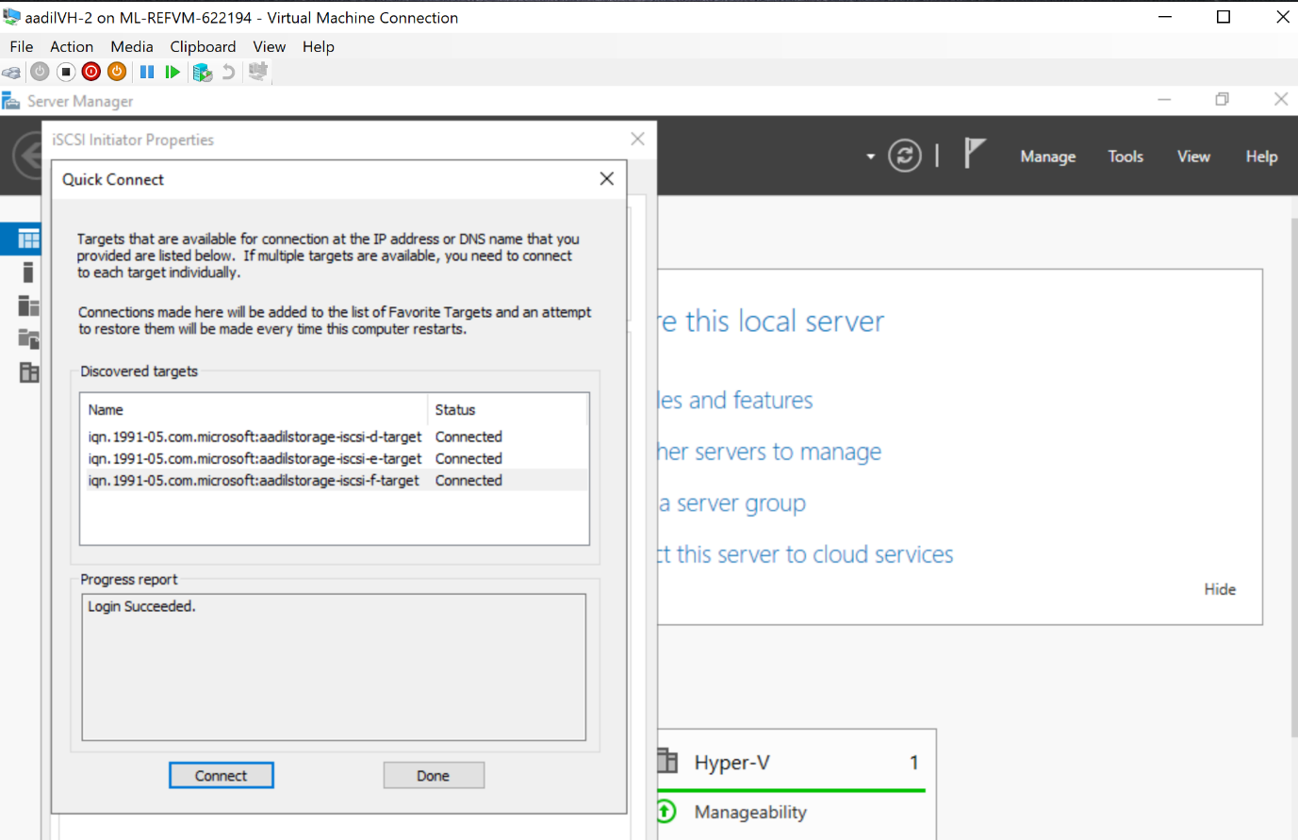

*Fig 6.4 (iSCSI disk Connected to aadilVH-2)*

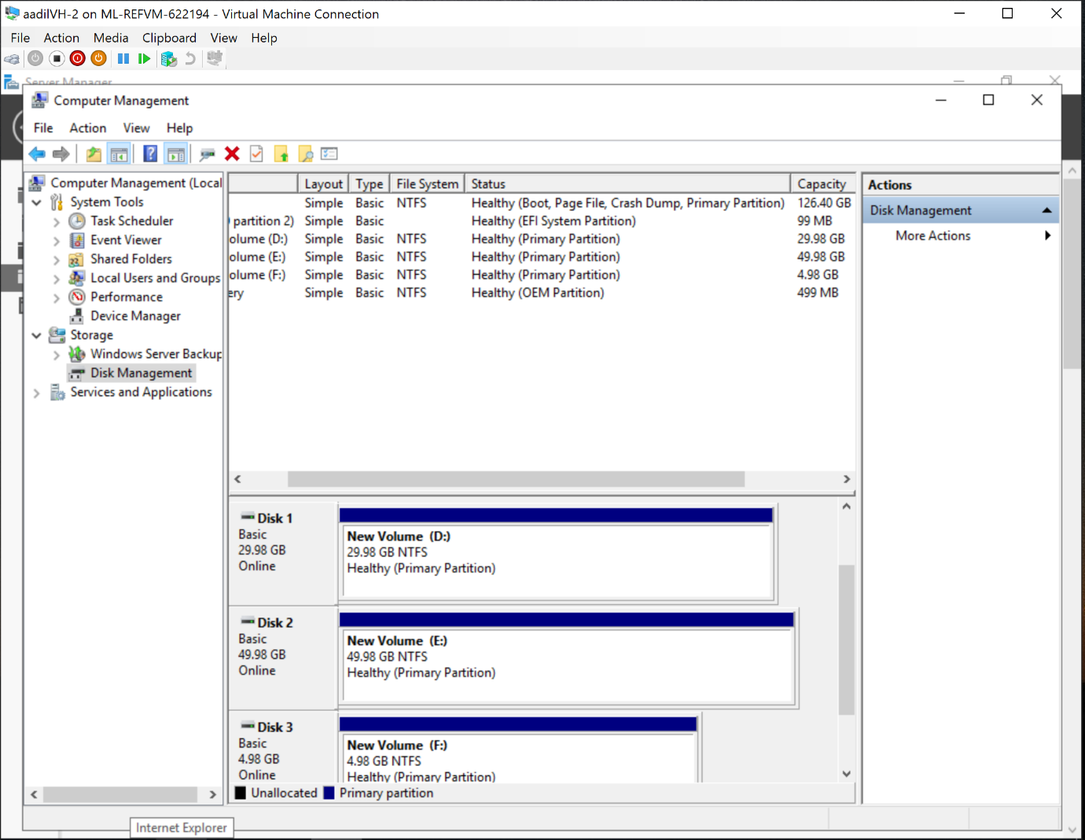

*Fig 6.5 (iSCSI disks Initialized to aadilVH-2)*

1. Failover Cluster and Live migration Scenario

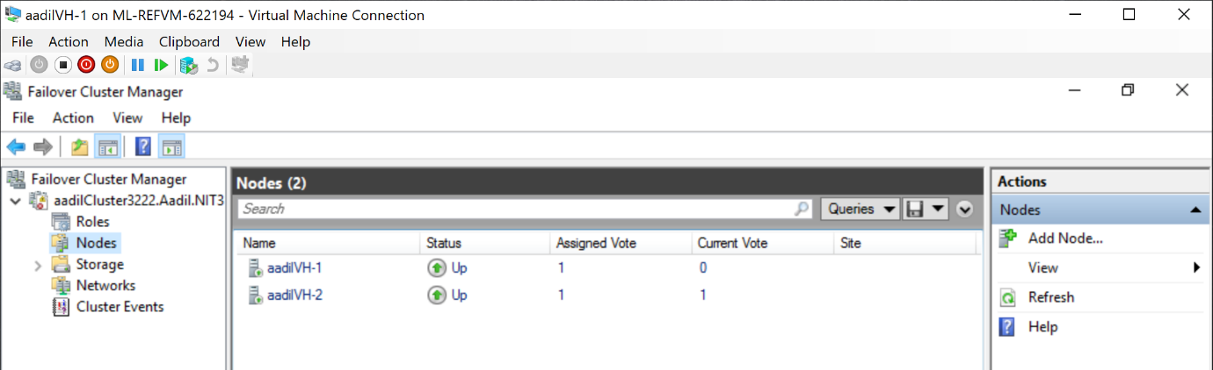

*Fig 7.1 (Representation of Failover Cluster aadilCluster3222 Cluster and Nodes aadilVH-1, aadilVH-2)*

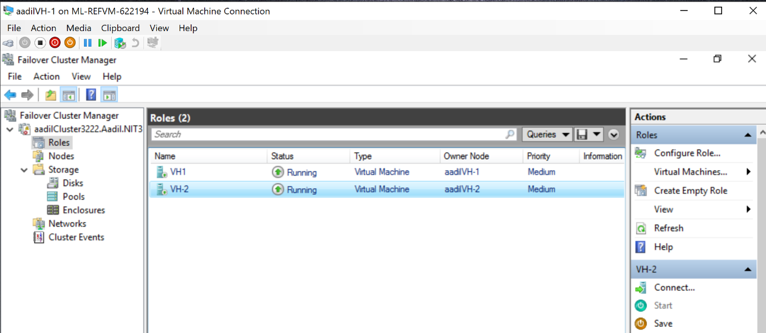

*Fig 7.2 ( High Available Roles from both Nodes)*

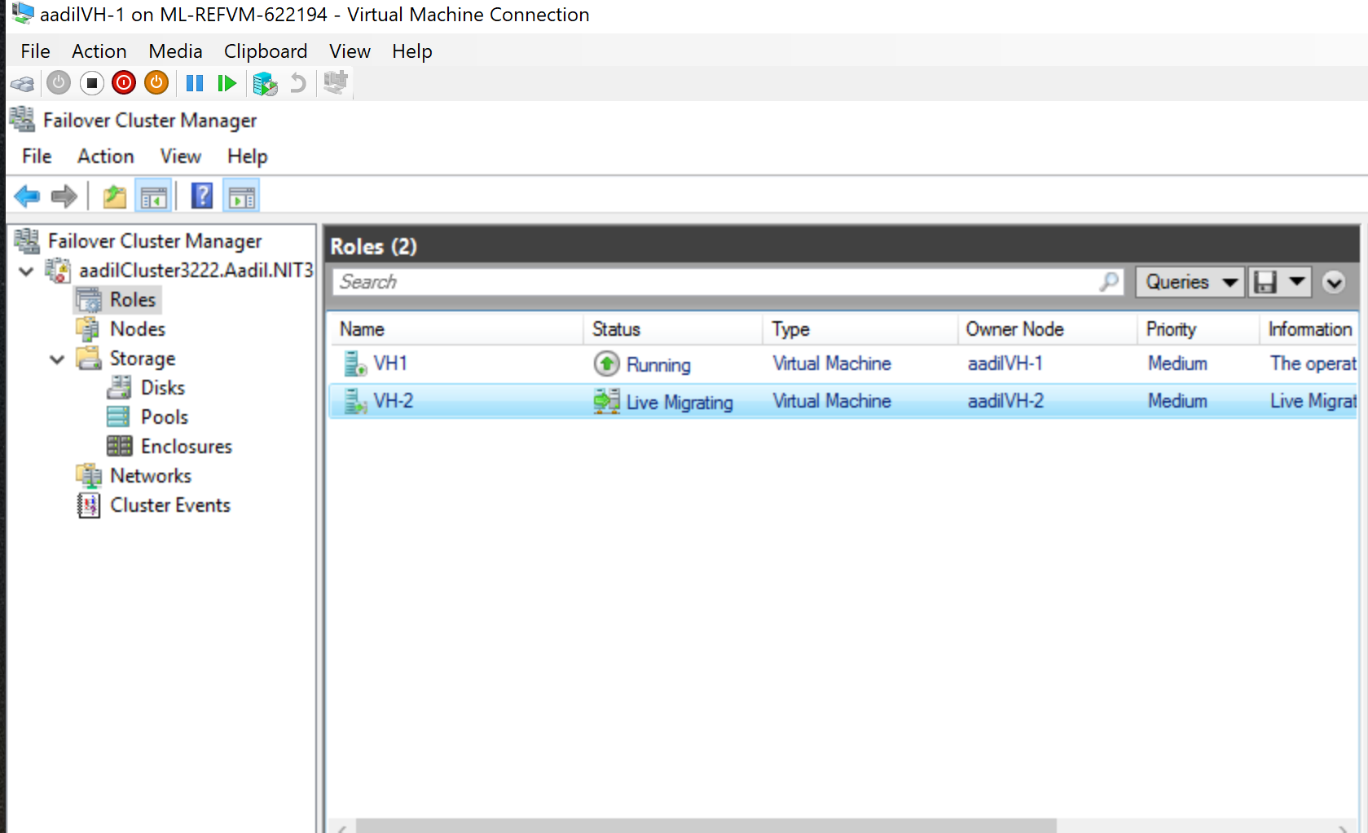

*Fig 7.3 (Live Migration from VH-2 to VH-1)*

*Both the Roles Belong to different Nodes. Once Live migration is done, the ownership status is changed accordingly*

***High Available Scenario***

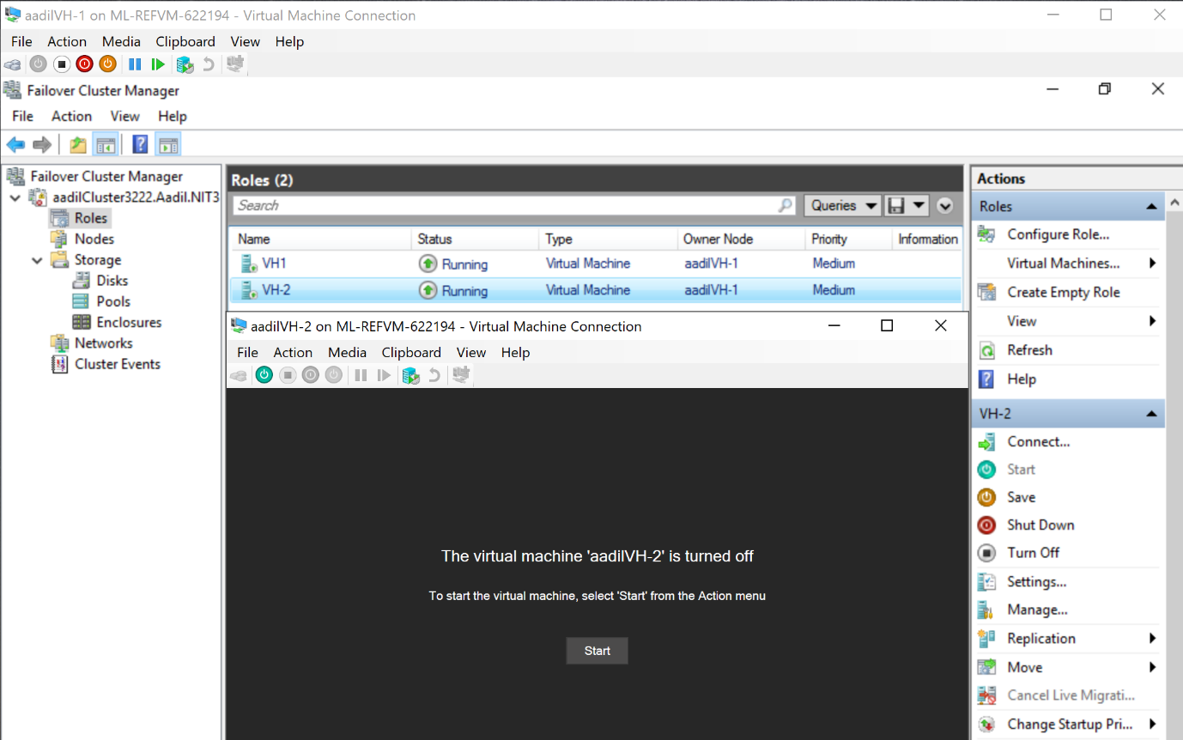

***This scenario represents the High availability of the Virtual machine. Application Server***

***aadilVH-2 is turned off to show that the virtual Machine VH-2 is still up and running***

***Additional Requirements***

***Requirements***

Small Industrial PC spare parts company Called ‘Aadil08’ wants to set up the computing environment for their Finance and Accounting Department with high available services. The design requested will consist of an Application server, Domain Controller and a Storage server.

The application server primarily focused on running the software and application required for the finance department will be used by Senior 2 accountants in their daily task. End of every week 1 more accountant will be joining them to support the final review done at the end of each week. The server will host two Virtual Machines (aadilVH-1, aadilVH-2) one as a running application server in use and the other as running backup for failover cluster. Both the VMs embedded in one cluster

The Domain controller server here is the main computer that controls our other servers with active directory services. (aadilADC)

The storage server (aadilStorage) is used mainly to store the application servers’ data. It is accessible by 50 Employees in the department for accounting references and repository. Server will consist of two storage disks (mStorage-1, mStorage-2). Both the Main application server and Fail over cluster are connect to the same storage server using it as a shared server. Consists of 4 iSCSI Disks which are shared

The Company’s environment will need the following implementation:

-Application Server

-Domain Controller

-Storage Server

-Failover cluster with Two Nodes

***Analysis and mapping to technical requirements***

‘Aadil Hardware’ Company is to setup the computing environment for their Finance Department. The department needs four servers, Failover Cluster server (aadilVH-1) for the accountants, Application Server (aadilVH-2), Storage server (aadilStorage) for shared storage access, Domain Controller (aadilADC). The department network segment is 172.20.10.0/24, gateway 181.20.81.1 (domain controller).

[technical requirement: Four VMs are required, with Four IPs in the range of 172.20.10.0/24.

**Design**

aadilADC: Domain Controller

CPU: 4 vCPUs

Memory: 3G

Hard Disk: 30G Non-Dynamic

Virtual Switches: aadilStorageNet, LabServicesSwitch

Networks and Macs

For aadilStorageNet: 181.20.81.1/24 00-00-03-90-01-01

For LabServiceSwitch: DHCP 00-00-03-90-01-02

Administrator Password: yuanStudy1

aadilVH-1: Application Server

CPU: 4vCPUs

Memory: 3G Non-Dynamic

Hard Disk: 90G Total Non-dynamic

Virtual Switches: aadilStorageNet, aadilHeartBeatNet, LabServicesSwitch

Networks and Macs

For aadilStorageNet: 181.20.81.101/24 00-00-03-90-02-01

For aadilHeartBeatNet: 172.20.20.101/24 00-00-03-90-02-02

For LabServicesSwitch: DHCP 00-00-03-90-02-03

Administrator Password: yuanStudy1

aadilVH-2: Failover Cluster Application Server

CPU: 4vCPUs

Memory: 3G Non-Dynamic

Hard Disk: 90G Total

Virtual Switches: aadilStorageNet, aadilHeartBeatNet, LabServicesSwitch

Networks and Macs

For aadilStorageNet: 181.20.81.102/24 00-00-03-90-03-01

For aadilHeartBeatNet: 172.20.20.102/24 00-00-03-90-03-02

For LabServicesSwitch: DHCP 00-00-03-90-03-03

Administrator Password: yuanStudy1

aadilStorage: Shared Storage access

CPU: 3vCPUs

Memory: 3G Dynamic

Hard Disk: 515G Total

Virtual Switches: aadilStorageNet, LabServicesSwitch

Networks and Macs

For aadilStorageNet: 181.20.81.3/24 00-00-03-90-04-01

For LabServicesSwitch: DHCP 00-00-03-90-04-02

Administrator Password: yuanStudy1

***UPDATED CLUSTER COMPACT STRUCTURE***

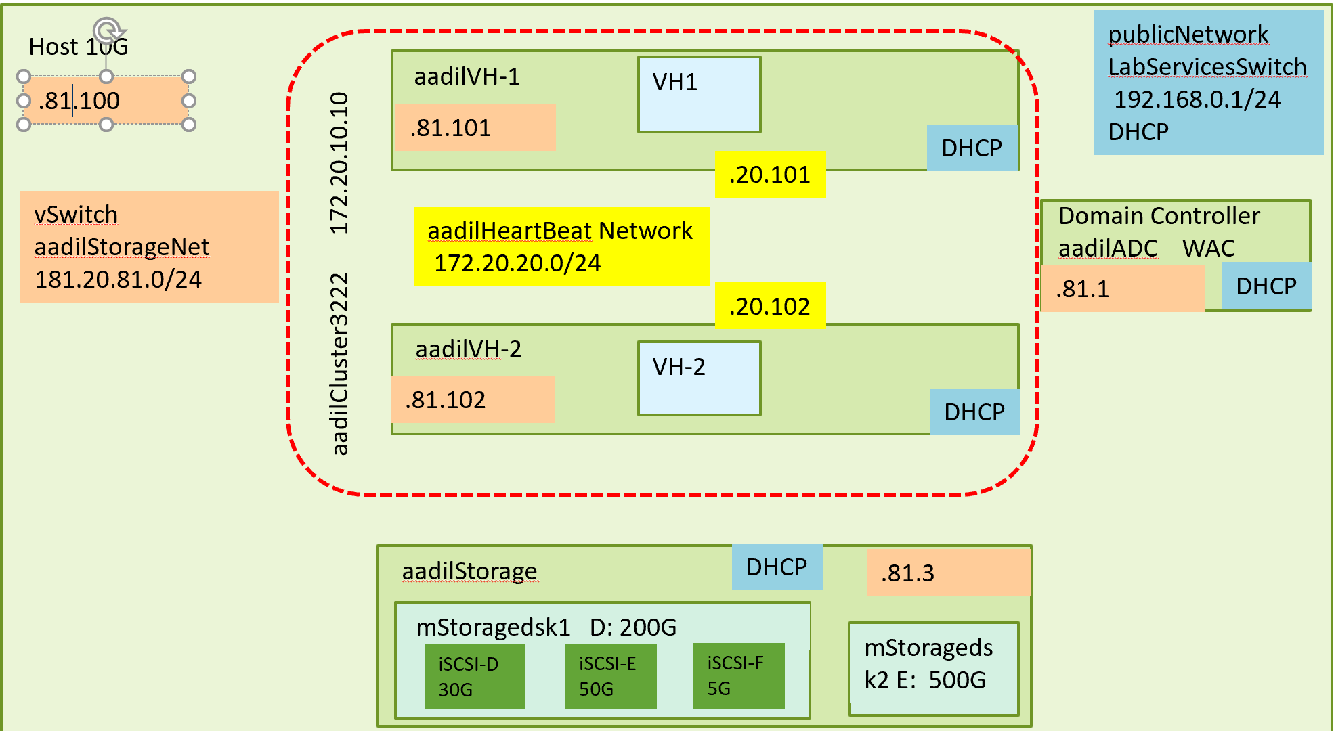

***BASIC REQUIREMENT***

1. Change the storage server storage network ip address to xxx.xxx.xxx.8b where b is the last digit of your student number. xxx can be any number or keep your original designed number.

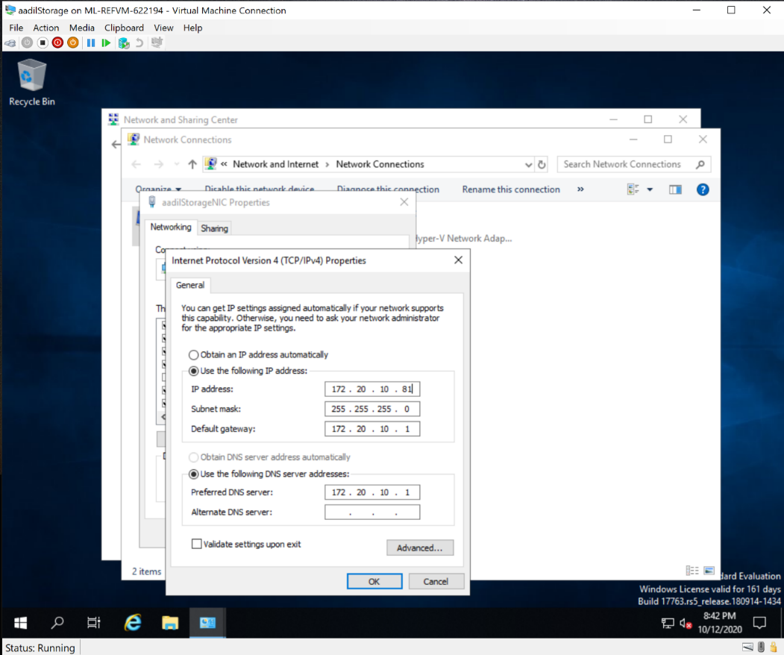

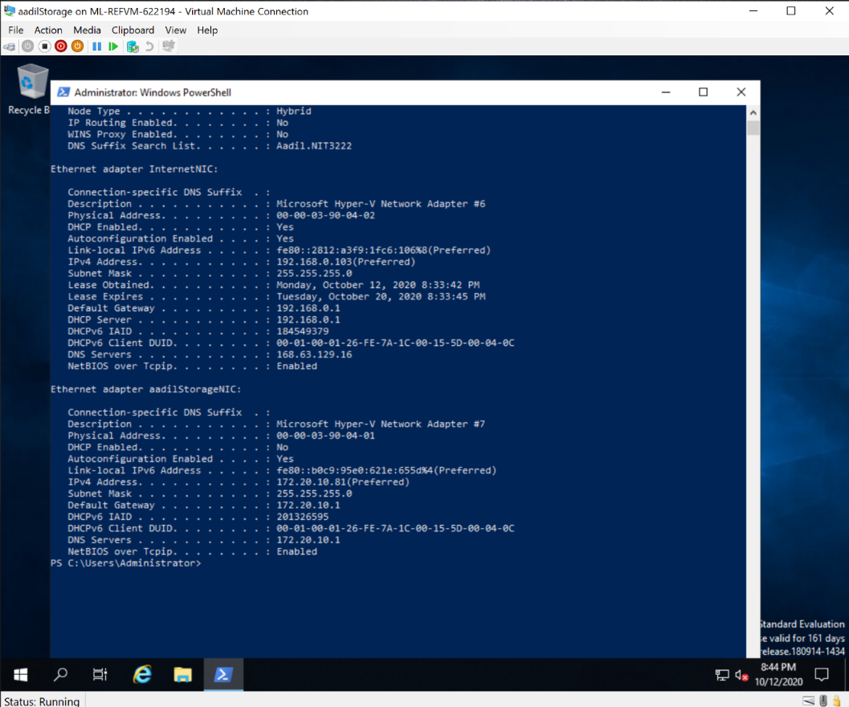

Ipconfig /all (storage server

1. Replace one of the iscsi virtual disks used as cluster storage for VMs (not Quorum) and the iscsi target with the name starting with your first name.

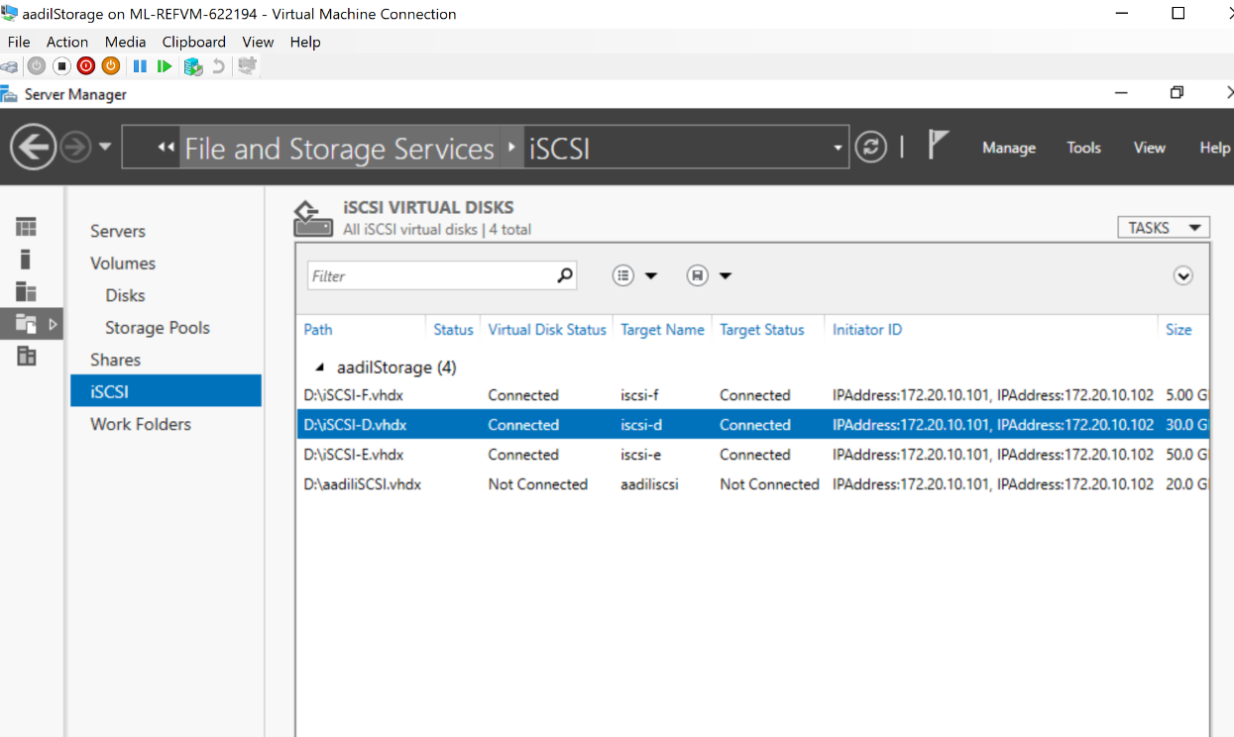

*aadilIsci disk Created under D storage disk*

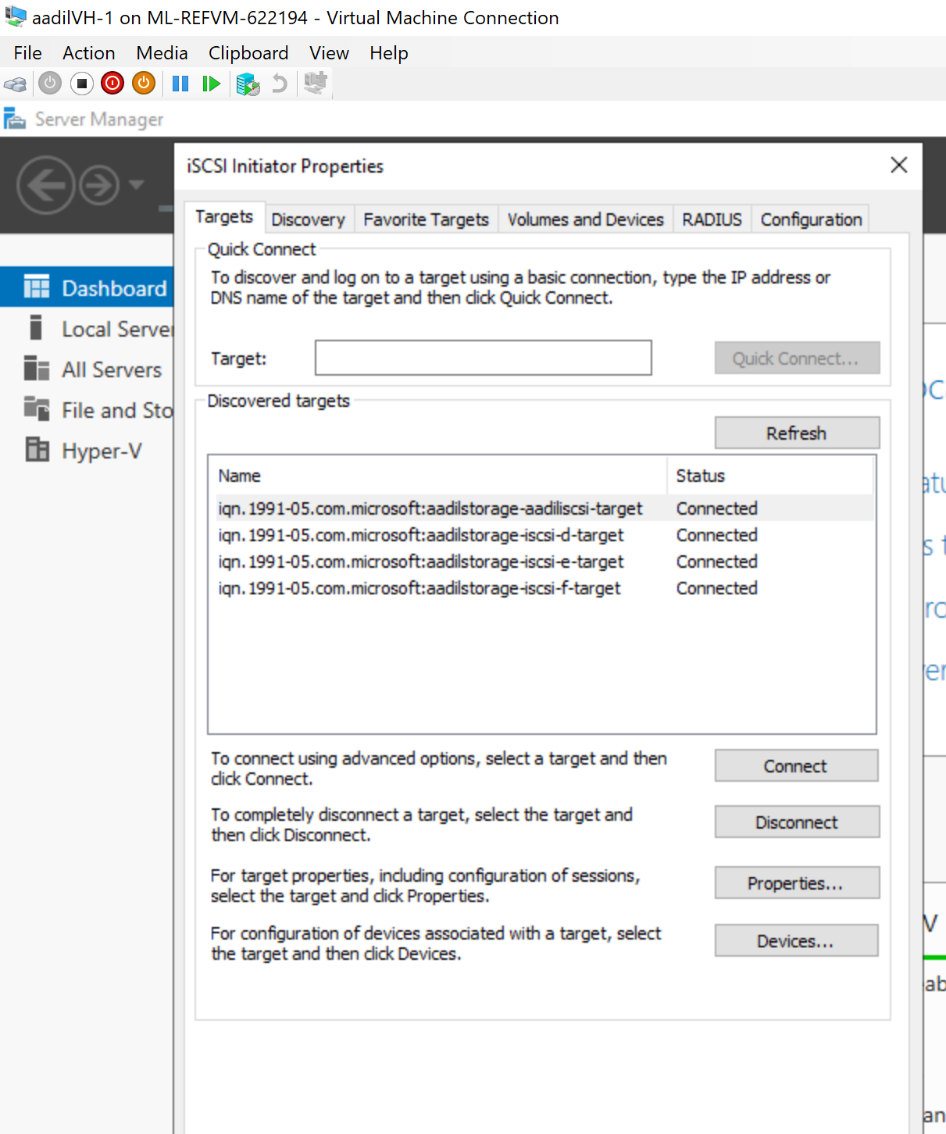

aadilVH-1 is connected to the new iSCSI Disk (aadiliSCSI)

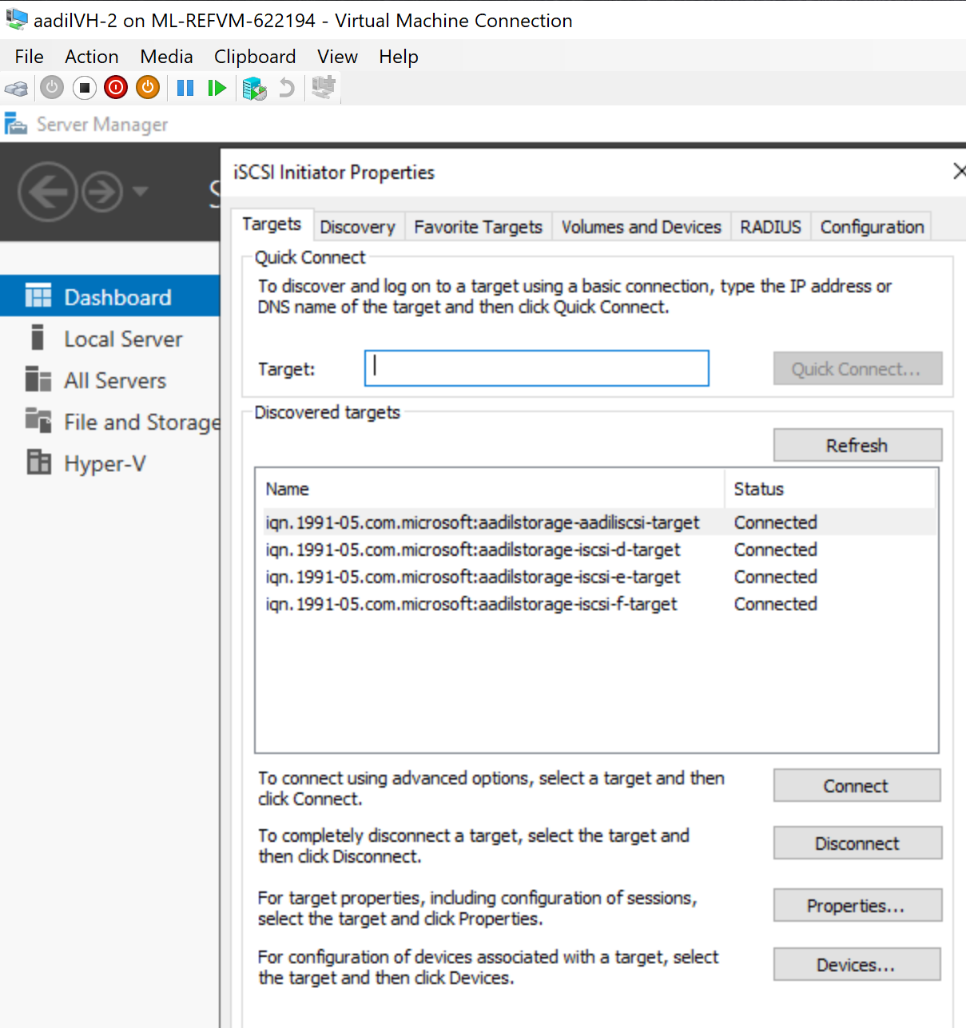

aadilVH-2 is connected to the new iSCSI disk (aadiliSCSI)

*New created disk Initialized on Both VMs (aadilVH-1 and aadilVH-2)*

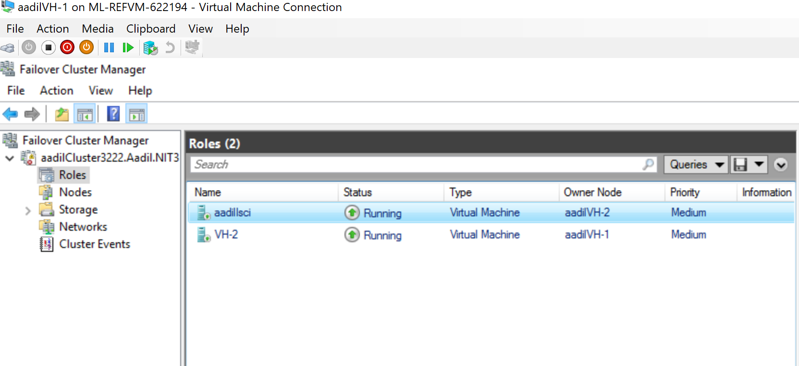

*New Role aadiliSCSI is created under the new iSCSI disk. (aadiliSCSI)*

3) Change one of the cluster nodes' (VH-1 or VH-2) name with your first name; change the storage network ip address to xxx.xxx.xxx.8a where a is the second last digit of your student number.

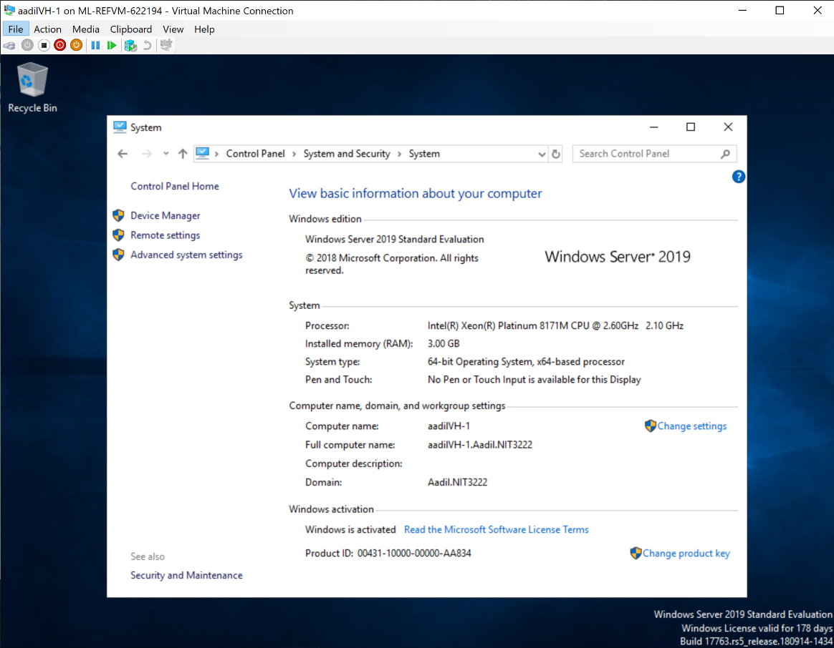

*Failover cluster Application server name is changed to aadilVH-1*

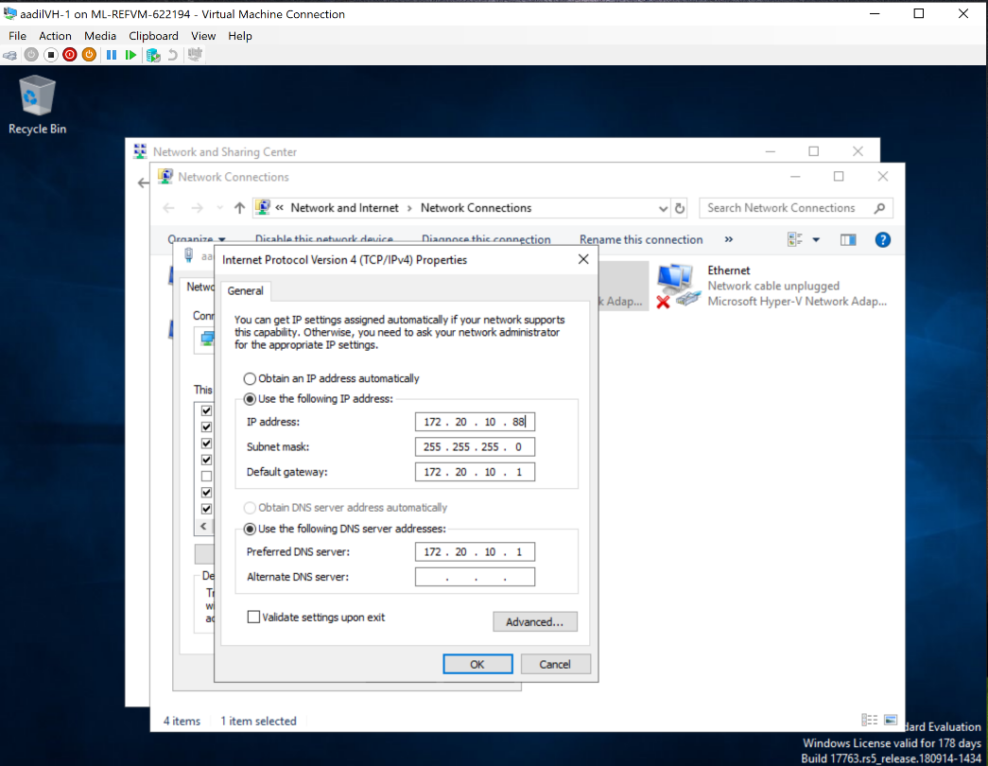

Steps to change the Ip address of Storage network for aadilVH-1

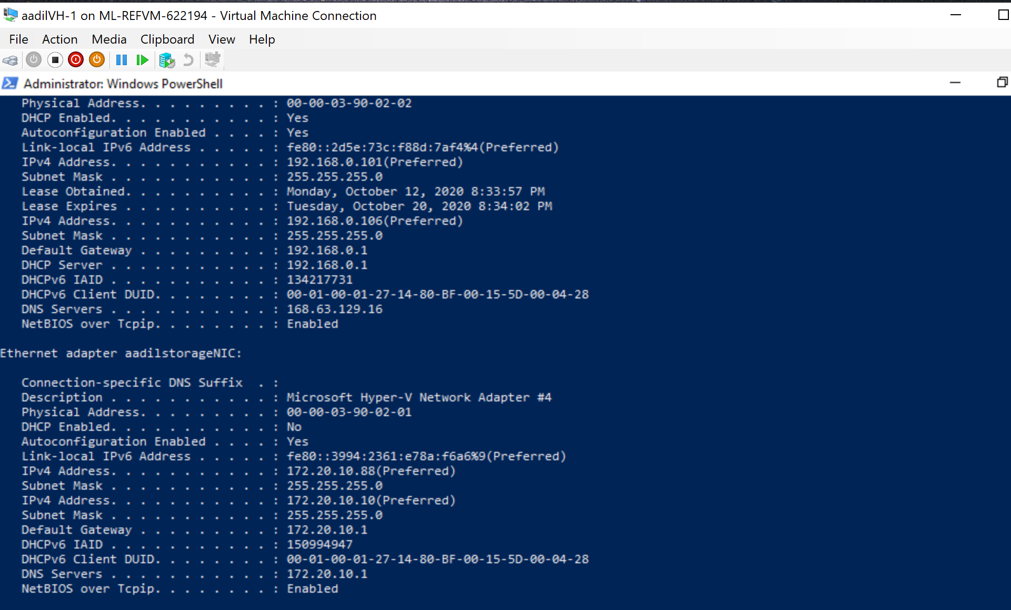

*Ip address Changed accordingly with the question(172.20.10.88)*

***ADVANCED REQUIREMENTS***

1. Change the storage network to ab.xxx.ab.0/24 where ab is the last two digits of your student number.

aadilVH-2 Application Server (Config Storage Network)

$VMName="aadilVH-2"

$adapters=@("aadilstorageNIC", "InternetNIC" ,"aadilHeartbeatNIC")

$mac1="00-00-03-90-03-01"

$mac2="00-00-03-90-03-02"

$mac3="00-00-03-90-03-03"

$macs=@($mac1,$mac2,$mac3)

$switches=@("aadilStorageNet", "LabServicesSwitch","aadilHeartbeatNet")

#config storage network

#--------------------------

$i=0

$mac1=$macs[$i]

$adaptername=$adapters[$i]

$ipadd='181.20.81.102'

$gateway='181.20.81.1'

$netif=(Get-NetAdapter | where {$_.MacAddress -eq $mac1}).InterfaceIndex

$netname=(Get-NetAdapter | where {$_.MacAddress -eq $mac1}).name

Remove-NetIpAddress -InterfaceIndex $netif -AddressFamily IPv4 -Confirm:$false

Remove-NetRoute -InterfaceIndex $netif -AddressFamily IPv4 -Confirm:$false

New-NetIPAddress -IPAddress $ipadd -prefixlength 24 -DefaultGateway $gateway -InterfaceIndex $netif

rename-netadapter -name $netname -newName $adaptername

#add dns

#set the dns server

set-DnsClientServerAddress -InterfaceIndex $netif -ServerAddresses ($gateway)

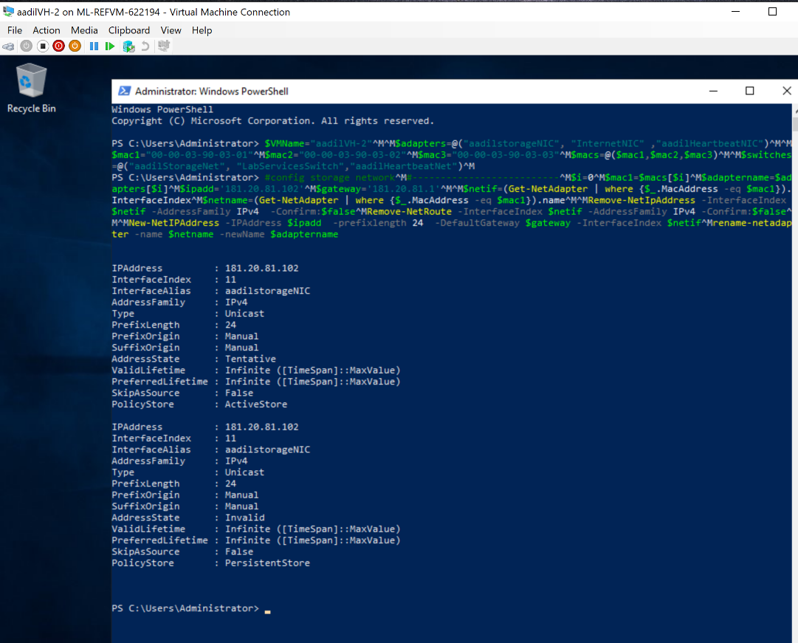

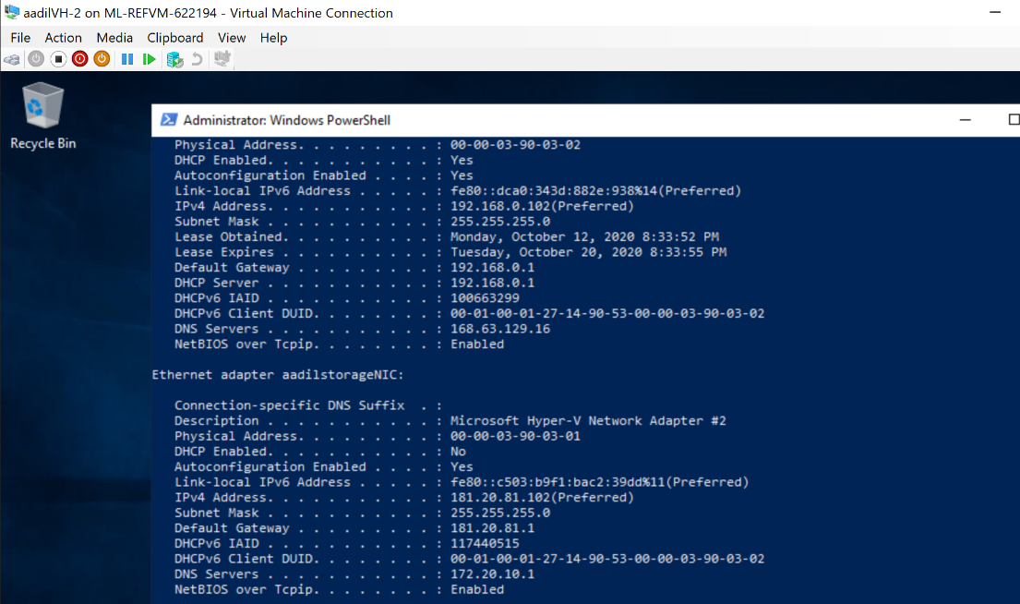

aadilStorage Server (config Storage Network)

$VMName="aadilStorage"

$adapters=@("aadilstorageNIC", "InternetNIC" ,"aadilHeartbeatNIC")

$mac1="00-00-03-90-04-01"

$mac2="00-00-03-90-04-02"

$mac3="00-00-03-90-04-03"

$macs=@($mac1,$mac2,$mac3)

$switches=@("aadilStorageNet", "LabServicesSwitch","aadilHeartbeatNet")

#config storage network

#--------------------------

$i=0

$mac1=$macs[$i]

$adaptername=$adapters[$i]

$ipadd='181.20.81.3'

$gateway='181.20.81.1'

$netif=(Get-NetAdapter | where {$_.MacAddress -eq $mac1}).InterfaceIndex

$netname=(Get-NetAdapter | where {$_.MacAddress -eq $mac1}).name

Remove-NetIpAddress -InterfaceIndex $netif -AddressFamily IPv4 -Confirm:$false

Remove-NetRoute -InterfaceIndex $netif -AddressFamily IPv4 -Confirm:$false

New-NetIPAddress -IPAddress $ipadd -prefixlength 24 -DefaultGateway $gateway -InterfaceIndex $netif

rename-netadapter -name $netname -newName $adaptername

#add dns

#set the dns server

set-DnsClientServerAddress -InterfaceIndex $netif -ServerAddresses ($gateway)

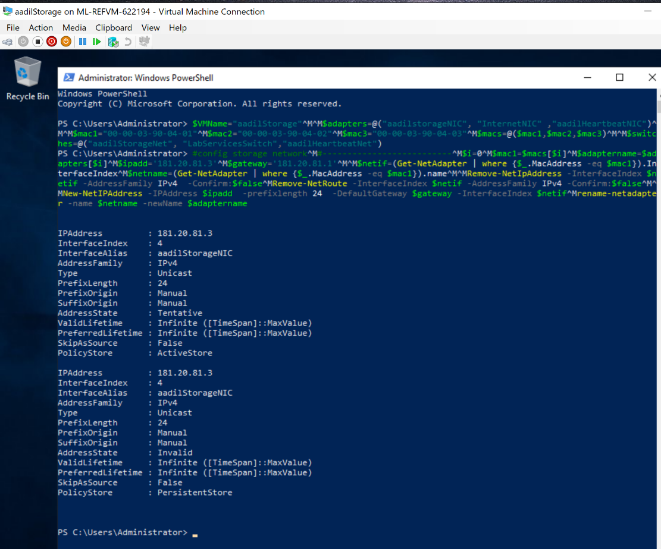

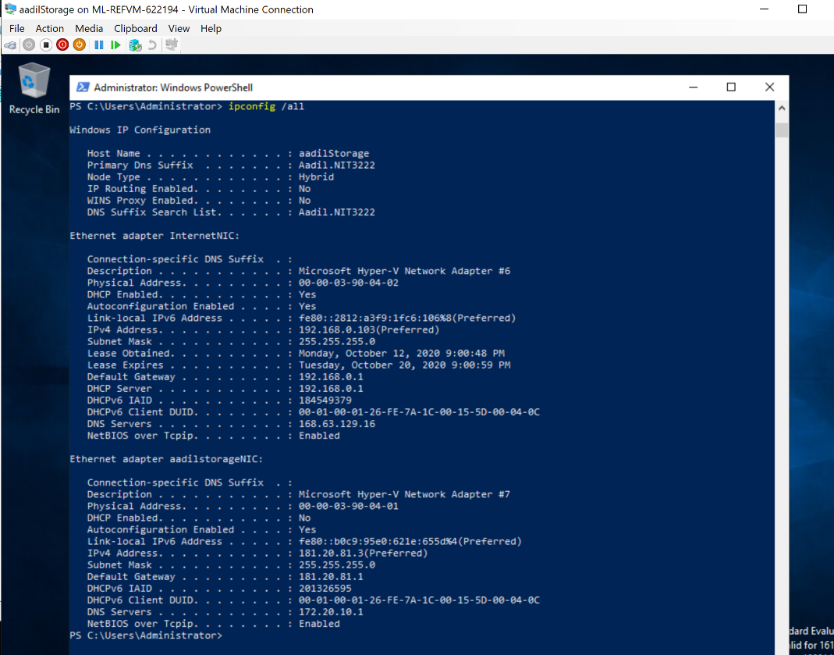

aadilADC Domain controller (config Storage Network)

$VMName="aadilADC"

#define an array of adapter names

$adapters=@("aadilstorageNIC", "InternetNIC" ,"aadilHeartbeatNIC")

$mac1="00-00-03-90-01-01"

$mac2="00-00-03-90-01-02"

$mac3="00-00-03-90-01-03"

$macs=@($mac1,$mac2,$mac3)

# note the mac range needs to be valid

# array of switch names

$switches=@("aadilStorageNet", "LabServicesSwitch","aadilHeartbeatNet")

#Config AD VM --- NIC

#config storage network

#--------------------------

$mac1="00-00-03-90-01-01"

$adaptername=$adapters[0]

$ipadd='181.20.81.1'

$gateway='181.20.81.1’

#based on the mac address to find the adapter’s interface netif

$netif=(Get-NetAdapter | where {$_.MacAddress -eq $mac1}).InterfaceIndex

$netname=(Get-NetAdapter | where {$_.MacAddress -eq $mac1}).name

#remove the existing IP to add new address

Remove-NetIpAddress -InterfaceIndex $netif -AddressFamily IPv4 -Confirm:$false

Remove-NetRoute -InterfaceIndex $netif -AddressFamily IPv4 -Confirm:$false

New-NetIPAddress -IPAddress $ipadd -prefixlength 24 -DefaultGateway $gateway -InterfaceIndex $netif

rename-netadapter -name $netname -newName $adaptername

#add dns

#set the dns server

set-DnsClientServerAddress -InterfaceIndex $netif -ServerAddresses ($gateway)

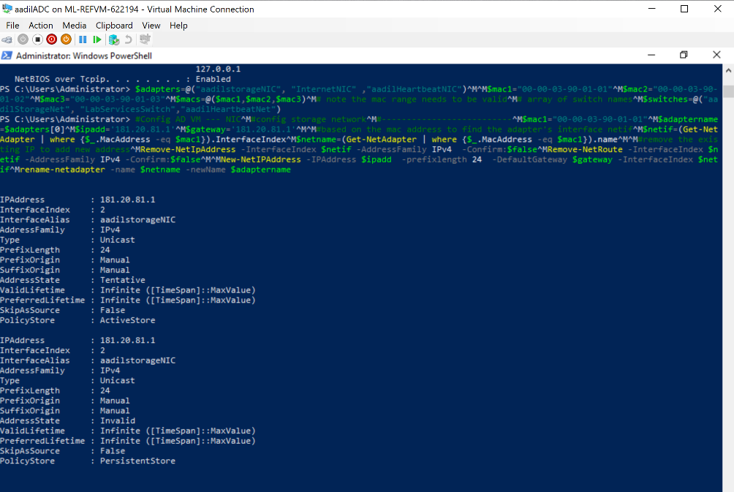

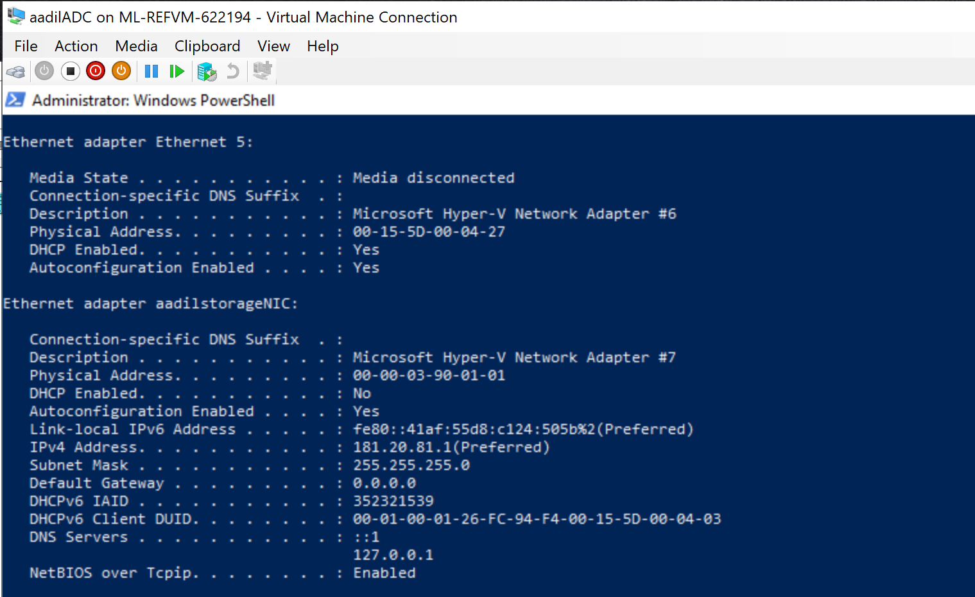

aadilVH-1 Failover Cluster Application Server ( Config Storage Network )

$VMName="aadilVH-1"

$adapters=@("aadilstorageNIC", "InternetNIC" ,"aadilHeartbeatNIC")

$mac1="00-00-03-90-02-01"

$mac2="00-00-03-90-02-02"

$mac3="00-00-03-90-02-03"

$macs=@($mac1,$mac2,$mac3)

$switches=@("aadilStorageNet", "LabServicesSwitch","aadilHeartbeatNet")

#config storage network

#--------------------------

$i=0

$mac1=$macs[$i]

$adaptername=$adapters[$i]

$ipadd='181.20.81.101'

$gateway='181.20.81.1'

$netif=(Get-NetAdapter | where {$_.MacAddress -eq $mac1}).InterfaceIndex

$netname=(Get-NetAdapter | where {$_.MacAddress -eq $mac1}).name

Remove-NetIpAddress -InterfaceIndex $netif -AddressFamily IPv4 -Confirm:$false

Remove-NetRoute -InterfaceIndex $netif -AddressFamily IPv4 -Confirm:$false

New-NetIPAddress -IPAddress $ipadd -prefixlength 24 -DefaultGateway $gateway -InterfaceIndex $netif

rename-netadapter -name $netname -newName $adaptername

#add dns

#set the dns server

set-DnsClientServerAddress -InterfaceIndex $netif -ServerAddresses ($gateway)

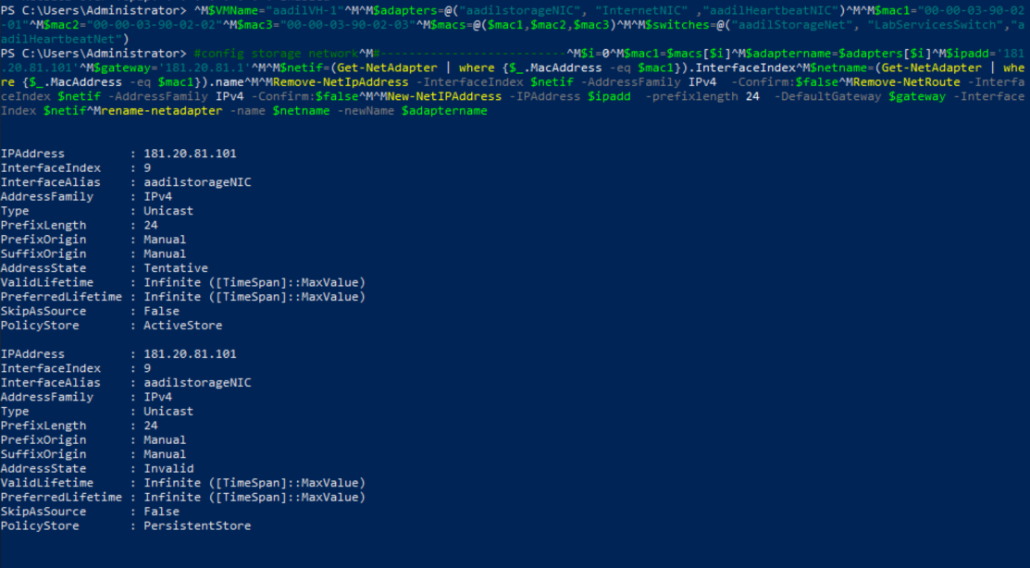

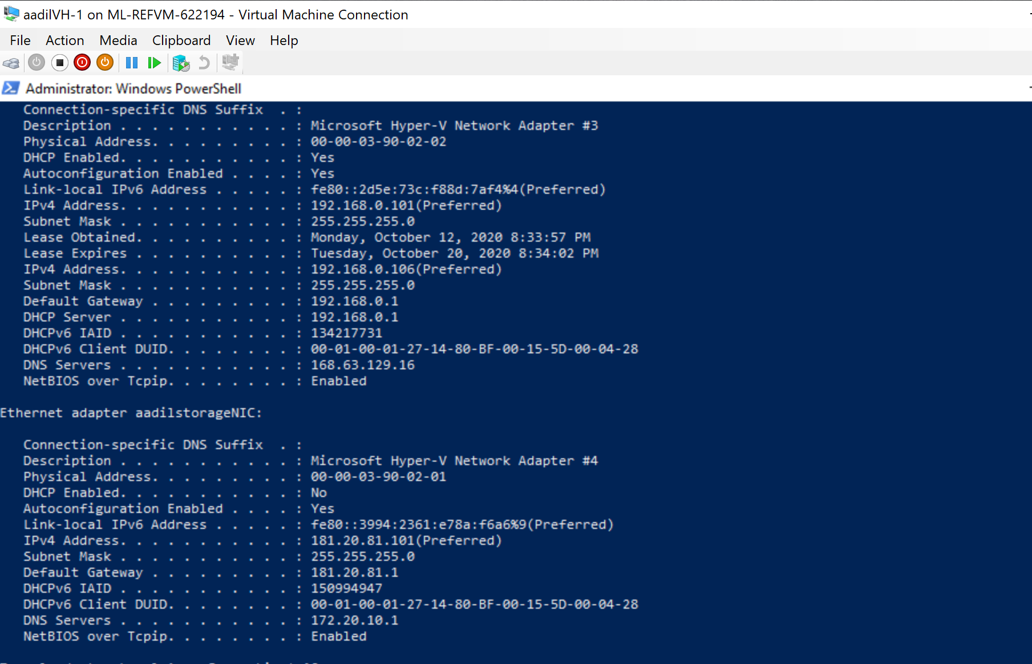

1. Change the company name as your first name followed by 08, and cluster name needs to be the same as your company name.

Company name is changed to aadil08. Cluster name is named after the Company

